Quattro Micro Guide to Tuning

1 Introduction

1.1 Aim
This document is designed to act as reference information for tuning the Quattro Micro. This document will simply give information about what the lenses do and what typical values are
This document is intended as a guide to common samples that you will see but is not intended as a definative guide to all samples that you will encounter on site.

1.2 Abbreviations
Abbreviations used in this manual.
APCI Atmospheric chemical ionisation
ESI Electrospray Ionisation

1.3 Hazards
WARNING. There are high voltages and hot surfaces present throughout the mass spectrometer. Only suitably trained personnel, aware of the inherent hazards and observing every precaution must perform work on this instrument. When ever possible the power supply should be isolated before working on the instrument. Where it is necessary to work on the instrument live, only suitably trained staff should be employed.

2 Source Tuning

The screen shot below shows the tuning parameters from a typical Quattro Micro tune page in ESI mode:
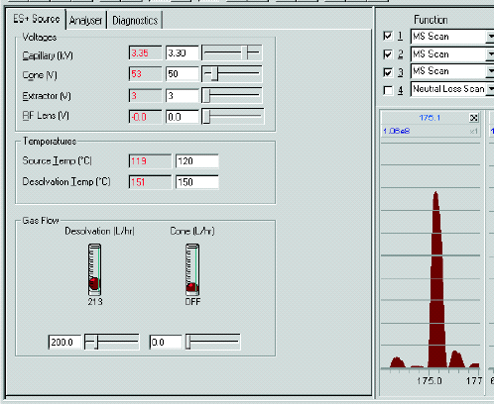
The parameters selected will have a direct effect on the sensitivity of the instrument. We will look at each in turn and explain what it does.

2.1 Capillary
The capillary is the voltage applied to the tip of the ESI probe. The Capillary voltage supplies a HV to the probe tip and gives the potential to the droplets of solvent as they are sprayed from the probe. The value of the capillary required to maximise the sensitivity on a particular sample will be dependant on the solution and sample composition.
The capillary usually tunes between 3 and 3.5 kV for maximum sensitivity on a compound in positive ion ESI but this can be reduced by adding acid to the mobile phase/sample as it increases the number of protons in solution.
Also addition of ionic buffers such as potassium phosphate will also reduce this value as they will adduct to the sample (rather than a proton). Likewise the presence of sodium or potassium ions in positive ion (usually present in biological samples) will reduce the capillary voltage required for maximum sensitivity.
Reducing the % of water in the solvent composition will increase the capillary voltage required to maximise sensitivity on a sample. This is why in gradient HPLC the tuning for a sample in 50:50 acetonitrile:water may not give the best sensitivity when a sample elutes.
In negative ion the capillary usually tunes between 2.5kV and 3.0kV for maximum sensitivity on a sample. The addition of a proton acceptor such as ammonium hydroxide will reduce the capillary voltage required to ionise the sample.
Note: Tuning on solvent ions will often require a capillary voltage between 4.2 and 5.0kV to maximise sensitivity upon them.

2.2 Corona
The Corona is the current applied to the corona needle in APCI ionisation and serves a similar purpose as capillary in ESI. The Corona is used to charge a cloud of gas through which the sample passes on its way into the instrument. This cloud transfers charged protons to the sample to cause ionisation.
The values for corona will depend again on solvent composition with aqueous samples requiring a lower corona voltage than more organic rich mobile phase. Typical values are between 2 and 10 μA for 50:50 acetonitrile:water.

2.3 Probe position adjuster
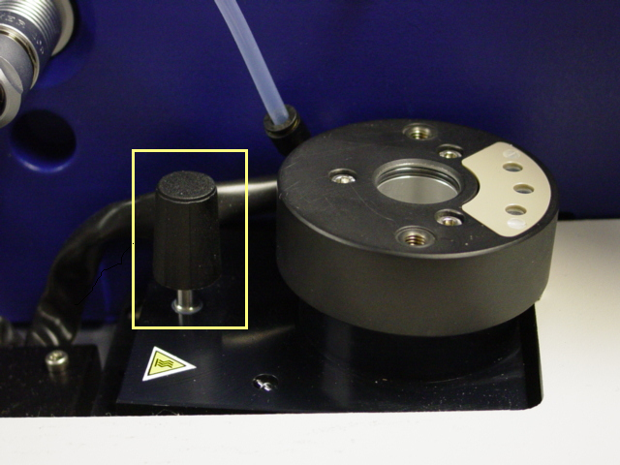The probe position can be controlled by the black knob shown in the photograph below.
The probe position may need to be adjusted between APCI and ESI to maximise sensitivity. Also different flow rates and solvent compositions create different cones of spray from the tip of the probe in ESI and this may need to be adjusted to maximise the sensitivity.
2.4 Cone
The cone is the voltage applied to the sample cone on the source of the Quattro Micro. The cone voltage has two processes that control the tuning voltage for a compound.
The first process that effects the cone voltage required for a particular compound is mass. The heavier a compound the more cone voltage that it will require to maximise sensitivity. This is because the rear of the sample cone acts as an acceleration lens and dictates the velocity of ions travelling into the source. If the velocity is too high then the ions are less likely to travel into the extractor.
The second process that effects the cone voltage required for a particular compound is cone voltage fragmentation. Cone voltage fragmentation is an effect that causes samples to be fragmented in the sample cone due to collisions between molecules when high cone voltages are used.
The cone voltage fragmentation is an unimportant effect except in compounds with weak internal bonds. If the bonds are weak then the compound is more likely to fragment and the lower the cone voltage that this effect occurs, in some causes this may occur at voltages lower than the optimum tuning at process one above.
Typical cone voltages are shown below:

Solvents: 20-35V
Raffinose (503): 45
Reserpine (609): 60-70V
PPG2000 (2010): 90-120V

The actual voltage on the sample cone is the set cone voltage + set extractor voltage + set RF Lens voltage. This is to ensure a potential gradient exists as the ions enter the source.

2.5 Extractor
The extractor is the voltage applied to the extractor lens to attract ions around the final leg of the "Z" of the source. This voltage typical tunes around 3V and is not dependant on other factors. The actual voltage on the extractor is set extractor voltage + set RF Lens voltage.

2.6 RF Lens
The RF lens has two voltages applied to it, one is an RF potential and the other is a DC potential. The RF potential is derived from the RF on the first quadrupole and is not a tuneable value.
The DC potential on the RF Lens is tuneable on Masslynx and can be set between 0 and 1V. This potential can be used as an acceleration effect to ensure that ions traverse the hexapole. Typically this is set to 0V (i.e. not used) but when the hexapole starts to become dirty or with higher mass ions a voltage of up to 0.3V may increase sensitivity.

2.7 Source Temperature
The temperature of the source is used to ensure that solvents and sample do not condense in the source. The value set depends on flow rate and percentage of water in sample/mobile phase.
Typically at 10μl/min with 50:50 Acetonitrile:Water a temperature of between 80-100c is used. As flow rate is increased so should temperature likewise be increased until a maximum of 150c is reached at a flow rate of 150μl/min.
If more water is present in the mobile phase then approximately 5c for every 10% more water should be increased.
Note that some compounds may be thermally unstable and require a lower source temperature than suggested by the flow rate.

2.8 Desolvation Temperature
This is the temperature on the heater that warms the desolvation gas that is used to desolvate the sample. Again, this temperature is directly related to the flow rate and solvent composition of the sample and is typically set to a temperature of between 80-100c at 10μl/min with 50:50 Acetonitrile:Water as solvent. As flow rate is increased so should temperature likewise be increased until a maximum of 350c is reached at a flow rate of 150μl/min.

2.9 Desolvation Gas
The desolvation gas is the amount of nitrogen used to remove solvent from the sample. Typically this is set at 500-600 l/hour at 10μl/min and increased up to 800-1000 l/hour at a flow rate of 150μl/min. Failure to increase the flow rate may result in solvent condensing on the inside of the source and reducing sensitivity

2.10 Cone Gas
Cone gas is used to reduce solvent clustering around ions especially when they are ionic. This is typically unused although at flow rates around 10μl/min may be set up to 50 l/hour to stabilise the beam.

2.11 APCI Probe temperature
This is used instead of the desolvation temperature to remove solvent from sample in APCI mode. This temperature is directly related to the volatility of the compound being analysed as it has a direct effect on the sensitivity.
Volatile compounds such as pesticides like temperatures below 350c. Moderately volatile compounds such as hormones like 350-500c, while unvolatile compounds such as reserpine like temperatures above 500c.
Care should be taken as many volatile compounds are thermally unstable and require a lower temperature to maximise sensitivity

3 Analyser Tuning

Analyser voltages are usually dependant on the mode the instrument is to be run in rather than the sample being analysed. We will now run through the analyser tuning parameters

3.1 MS1 Low Mass and High Mass Resolution.
These two voltages are controls of the resolution of the instrument and are used to control the RF/DC ratio of the instrument as it increases with mass.
These voltages only have an effect when the MS1 quadrupole is used to scan i.e. MS mode, Parent mode and Neutral loss. Typically in MS mode these are set to 15 and 15 to ensure that standard resolution is obtained from the instrument (i.e. a singly charged peak should a half height peak width of 0.4Da to 0.6Da). These voltages are also used in SIR and MRM and should be set to give a peak width at half height of less than 1.0Da.
If a peak is multiply charged then the resolution will have to be increased from 15/15 to obtain baseline resolution
Note: that these are called low mass and high mass resolution but should be called low and high effect. When setting resolution the high mass can be used for course setting while the low mass for fine setting.

3.2 MS1 Ion energy
The Ion energy is the difference between the DCs on opposing pairs of quadrupoles and is used to help ions traverse the quad. Normally this is set to a default of 0.5 when the quadrupole is used to scan. However, the optimum ion energy should normally be calculated (see procedure in 30149) and used when resolving in MS Mode, Parent or Neutral loss. Note that this value is sensitivity and negative values will result in the loss of beam.
When the quadrupole is not being used to scan then this should be set to 3V. In SIR or MRM modes this is usually set to around 1.0V.

3.3 Entrance and Exit voltages
These voltages help ions traverse the gas cell. In MS mode these voltage will typically maximise sensitivity at around 50V and are usually set there. In MS2 mode and MSMS they are set to 2V.
Tuning the entrance lens in MSMS may give greater sensitivity on a sample and it typical tunes between -5 and 2V (although never 0V). Note that in MSMS the collision energy is also applied to these lenses and this value is reflected in the readback.
In MSMS increasing the exit lens may reduce sensitivity slightly but will reduce any crosstalk due to a dirty gas cell.
3.4 Collision Gas
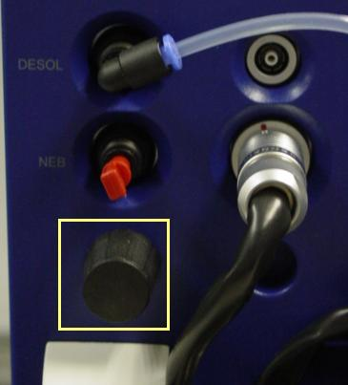
The control for the collision gas (argon) is shown in the photo below and is active only when the collision gas icon is toggled on. This knob is used to control the argon pressure inside the collision cell and usually tunes between 3.5 and 7.0 x10⁻³ mbar. Putting too much argon into the collision cell will cause the electronics to go into vacuum trip to prevent shorting occurring between the RF and DC on the quadrupoles at higher pressures.
This value is usually constant but may drift slightly over time.
Once set this value will hardly ever need to be checked.

3.5 Collision Energy
The collision energy is the DC voltage applied to the rods of the hexapole to accelerate the ions towards the argon in the collision cell to induce collision between them. For more information on the theory of MSMS collision see the how does it work document 30142.
The collision energy required for MS mode is usually 2V, in MSMS the collision energy will depend on the strength of the bonds inside the molecule as to how much energy is required to fragment them.
Typically compounds that are subject to lower cone voltage from cone voltage fragmentation will be subject to low collision voltage to fragment them in MSMS.

3.6 MS2 Low Mass and High Mass Resolution.
These two voltages are controls of the resolution of the instrument and are used to control the RF/DC ratio of the instrument as it increases with mass.
These voltages only have an effect when the MS2 quadrupole is used to scan i.e. MS2 mode, Daughter mode and Neutral loss. Typically in MS2 mode these are set to 15 and 15 to ensure that standard resolution is obtained from the instrument (i.e. a singly charged peak should a half height peak width of 0.4Da to 0.6Da). These voltages are also used in MRM and should be set to give a peak width at half height of less than 1.0Da.
If a peak is multiply charged then the resolution will have to be increased from 15/15 to obtain baseline resolution
Note: that these are called low mass and high mass resolution but should be called low and high effect. When setting resolution the High Mass can be used for course setting while the Low Mass for fine setting.

3.7 MS2 Ion energy
The Ion energy is the difference between the DCs on opposing pairs of quadrupoles and is used to help ions traverse the quad. Normally this is set to default of 0.5 when the quadrupole is used to scan. However, the optimum ion energy should normally be calculated (see procedure in 30149) and used when resolving in MS2 Mode, Daughter or Neutral loss. Note that this value is sensitivity and negative values will result in the loss of beam.
When the quadrupole is not being used to scan then this should be set to 3V. In MRM modes this is usually set to around 1.0V.

3.8 Multiplier
This is the voltage applied to the multiplier and determines the amplification effect of the detector. This is set to 650V for all operations on the Quattro Micro.

4 MS Settings for Set-up Solution

4.1 MS mode settings for set-up solution

This is for Set-up solution in ESI+ at 10μl/min
Capillary | 3.0 to 3.3kV
Cone | 65 to 70V
Extractor | 3 to 5V
RF Lens | 0 to 0.3V
Source Temperature | 80-100c
Desolvation Temperature | 150-200c
Cone Gas | 0-50 l/hour
Desolvation Gas | 500-600 l/hour

MS1 Low Mass Resolution | 15.0
MS1 High Mass Resolution | 15.0
Ion Energy1 | 0.5 (or optimum value)
Entrance | 50V
Collision Energy | 2V
Exit | 50V
MS2 Low Mass Resolution | N/A
MS2 High Mass Resolution | N/A
Ion Energy1 | 3.0
Multiplier | 650V

4.2 MS2 mode settings for set-up solution

Source settings are as MS1
MS1 Low Mass Resolution | N/A
MS1 High Mass Resolution | N/A
Ion Energy1 | 3.0
Entrance | 2V
Collision Energy | 2V
Exit | 2V
MS1 Low Mass Resolution | 15.0
MS1 High Mass Resolution | 15.0
Ion Energy1 | 0.5 (or optimum value)
Multiplier | 650V

4.3 MS mode settings for set-up solution

This is for Set-up solution in ESI- at 10μl/min (607 and 1054)
Capillary | 2.5 to 3.0kV
Cone | 40 to 40V
Extractor | 3 to 5V
RF Lens | 0 to 0.3V
Source Temperature | 80-100c
Desolvation Temperature | 150-200c
Cone Gas | 0-50 l/hour
Desolvation Gas | 500-600 l/hour

MS1 Low Mass Resolution | 15.0
MS1 High Mass Resolution | 15.0
Ion Energy1 | 0.5 (or optimum value)
Entrance | 50V
Collision Energy | 2V
Exit | 50V
MS2 Low Mass Resolution | N/A
MS2 High Mass Resolution | N/A
Ion Energy1 | 3.0
Multiplier | 650V

5 MSMS Settings for Reserpine

5.1 Daughter mode settings for reserpine

This is for Reserpine in ESI+ at 10μl/min
Capillary | 3.3 to 3.6kV
Cone | 60 to 65V
Extractor | 3 to 5V
RF Lens | 0 to 0.3V
Source Temperature | 80-100c
Desolvation Temperature | 150-200c
Cone Gas | 0-50 l/hour
Desolvation Gas | 500-600 l/hour

MS1 Low Mass Resolution | 14
MS1 High Mass Resolution | 14
Ion Energy1 | 2.0
Entrance | 2V
Collision Energy | 35-42V
Exit | 2V
MS2 Low Mass Resolution | 14.5
MS2 High Mass Resolution | 14.5
Ion Energy1 | 0.7
Multiplier | 650V

5.2 MRM mode settings for reserpine

This is for Reserpine in ESI+ at 300μl/min
Capillary | 2.8.to 3.2kV
Cone | 60 to 65V
Extractor | 3 to 5V
RF Lens | 0 to 0.3V
Source Temperature | 150c
Desolvation Temperature | 300-350c
Cone Gas | 0 l/hour
Desolvation Gas | 800-900 l/hour

MS1 Low Mass Resolution | 14
MS1 High Mass Resolution | 14
Ion Energy1 | 1.0
Entrance | -5 to 2V
Collision Energy | 35-42V
Exit | 2V
MS2 Low Mass Resolution | 14.5
MS2 High Mass Resolution | 14.5
Ion Energy1 | 1.0
Multiplier | 650V

