Quattro Micro - How does it work?

1 Introduction
This document is designed to familiarise you with the principles behind how the Quattro Micro works. The level of this document is designed as Level One although the information contained within is quite complex
The aim of this document is to introduce you to how the Instrument works. This information is essential for understanding how the instrument tunes. It is also essential for fault finding and troubleshooting.

1.2 Abbreviations
The following abbreviations have been used in this document.

Da Daltons (atomic mass units)
ESI Electrospray Ionisation
EPC Embedded PC
HV High Voltage
MRM Multiple Reaction Monitoring
MS Mass Separator
SIM Single Ion Monitoring
SIR Single Ion Recording

2 Probe and Source
This section will explain the theory behind the probes and sources that are used on the Quattro Micro.

2.1 ESI Probe

The ESI probe is not a standard design and cannot be used on other Micromass Instruments with a Z-Spray source. This is because the probe shaft has been specifically altered for the Quattro Micro. Despite this Electrospray theory is common between the different Micromass instruments.
Electrospray is one method for effecting this differential solvent removal also allowing the sample to be ionised in the process. To do this the solution is passed along a short length of stainless steel capillary tube, to the end of which is applied a high positive or negative electric potential, typically 3-4 kV. The solution reaches the end of the tube, nebuliser gas causes it to be almost instantaneously vaporized (nebulized) into a jet or spray of very small droplets of solution in solvent vapour.
In ESI the role of the probe is to simply ionise the sample and create a fine spray of the solvent that will allow it to evaporate easily in the source.
After this the solvent bubbles are introduced into the atmospheric area in front of the source visible through the glass source enclosure.
The diagram above shows the desolvation process in action with a typical solvent bubble.
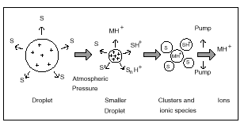As the droplets move through this region, solvent evaporates rapidly from their surfaces and the droplets get smaller and smaller. In addition to producing the spray, this method of rapid vaporization leaves no time for equilibrium to be attained and a substantial proportion of the droplets have an excess of positive or negative electrical charge which resides on their surfaces. Thus, as the droplets get smaller the electrical surface charge density increases until such time that the natural repulsion between like charges causes ions as well as neutral molecules to be released from the surfaces.
From here the ions pass into the source. Ions from electrospray have little excess of internal energy and therefore not enough energy to fragment. Many of the ions are of the form (M+X) + or (M-H) – in which X may be hydrogen or some other element such as sodium or potassium (known as adducting).
Most ions formed are singly charged however it is possible for an ion to pick up more than one ion. The Quattro Micro measures the ratio of m/z (mass to charge) not the mass of an ion, thus an ion of mass 1000 with a charge of 4 would appear as a mass of 250 in the Quattro Micro.

2.2 APCI Probe

APCI works in a similar way to ESI except that it sprays the solvent into the atmospheric source area by means of a fused silica capillary, thus no voltage is applied to the solvent as it leaves the probe. However, as the solvent leaves the probe it is heated up to a high temperature (depending on the chemical). The droplets created have a large surface area-to-volume ratio and solvent evaporates quickly.
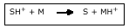
Inside the initial source area is a component called the corona pin, simply a metal pin that is charged to a high voltage. This pin has a cloud of ionised solvent and gas around it through which the sample has to pass. The charge is passed to the sample through a process known as proton transfer:
In this way the ions created are usually the protonated molecular mass so this technique is less liable to the formation of adducts.

The ions are attracted into the vacuum while the solvent ions are removed to exhaust.
2.3 Nano LC
The principles behind the Nano LC probe are identical to those of electrospray where the solvent is sprayed through a charged metal capillary. In Nano LC the whole probe is charged up to the capillary voltage and care should be taken when adjusting the probe during normal operation. The main difference between the Nano LC sprayer and the ESI probe is the solvent volumes the probes are able to cope with. Electrospray can run with solvent flows between 3µl/min and 1ml/min. Nano LC can cope with flows between 3µl/min and 200nl/min.
The other difference between the ESI probe and the Nano LC probe is its construction the Nano LC Probe should be assembled by the installing engineer during installation and should be maintained by the customer. The construction of the probe is tricky and can lead to delays in the flow if constructed incorrectly.

2.4 Capillary Electrophoresis
Very similar to the Nano LC Probe, the CE Probe is an interface between the Quattro Micro and an external capillary electrophoresis system.
CE relies on High Voltage being applied to a mixture of proteins and peptides. The components electrically separate due to a property of peptides and proteins that they have both a positive end and a negative end whose strength is determined by the bit in between.
In this way, some proteins are strongly negative, some are neutral and some are strongly positive. Thus when a fixed voltage is applied to a fused silica tube full of solvent, the speed they migrate away from the charge depends on their positive/negative properties.
The main function of the probe is to separate the high potential applied to the fused silica from the capillary voltage. Also there needs to be a solvent applied to the flow from the fused silica as the volumes can be quite low. At times this may stop so a "make up" flow is required to ensure that there is a stable baseline in the acquired chromatogram.

2.5 MUX
The MUX probe is a bolt on front end that replaces the ESI probe and the source enclosure. It allows a number of different LC flows to be coupled to a single Quattro Ultima so that up to four unique LC experiments can be run on a single instrument. Although there are a number of different MUX interfaces including 4way, 5way, 8way and 9way; the only interface that works on the Quattro Micro is the 4 way.
The MUX system works in an identical way to electrospray except that each of the four sprayers are aimed at a rotating chamber that is centred on the sample cone of the source. The rotating chamber moves between sprayers in turn and allows only a single sprayer to spray onto the sample cone preventing cross contamination between channels.
2.6 Sources
On the Quattro Micro there is only a single LC source although there are a number of different bolt on options that can replace the source enclosure on the front of the instrument.
The next component the ions enter is the source and is the piece at the front of the MS with the glass enclosure. The source on the Quattro Micro is called the Z-Spray source named after the shape of the path the ions take to enter instrument.
The source comprises the source block on the front and the hexapole behind this. Each of these areas is of increasing vacuum and the sources first role is as to step down the ion from the external atmospheric pressure to the vacuum pressure of the analyser.
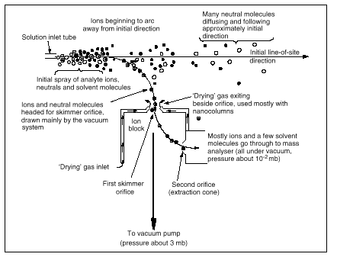
Solution issues from the end of the probe, solvent evaporates from these droplets. Under the influence of the general gas flow towards the vacuum pumps, and partly due to the electric fields, ions and neutral molecules move in an arc through cone, as shown. After this opening, a split between ions and neutral molecules is effected. Most remaining solvent and other neutrals flow on towards the first-stage vacuum pump. A few neutrals diffuse through the extractor, because of the differences in pressures on either side of it. Note the overall flattened Z-shape of the ion trajectory.

The Z- spray source can also be used to create fragments of the compound being sampled in a process known as cone voltage fragmentation. This occurs when the sample cone is set higher than its optimum value for a compound or mixture causing lower mass ions to slow down in the first vacuum area and cause collisions to occur. The difference in energy between the two colliding ions will determine the energy transferred in the collision and will control the bonds being broken in the collision.

The ion next enters a region that is of a higher vacuum, to get through this region the ion is passed into a hexapole, a set of six rods. The hexapole allows all ions in a beam to pass through whatever their m/z values. In passing through the rods the potential energy of the ions is controlled, the ion beam is also constrained preventing it from spreading outwards in a cone so that it leaves the hexapole as a narrow beam. This is important because the ion beam from the early source tends to spread due to mutual ion repulsion and collision with residual air and solvent molecules. By injecting this divergent beam into the hexapole, it can be ‘refocused’.
The differences between the kinetic energy of the fastest and slowest ions is a property known as ion energy spread and is a diagnostic tool.

3 Analyser

The next component that we are going to consider is the analyser the part of the instrument that is used to separate or filter the ions. The principle behind the analyser is the quadrupole, metal rods that use high frequency electric fields to separate out the ions.
The analyser on the Quattro Micro is commonly referred to as a triple quad despite the fact that there are only two quadrupoles inside it. This is because the earliest variants of the instrument used a third Quadrupole to create fragments, a role replaced by the hexapole of the gas cell.
The analyser of the Quattro Micro is split into three separate areas referred to as the MS1 Quad, the Gas cell and the MS2 Quad.

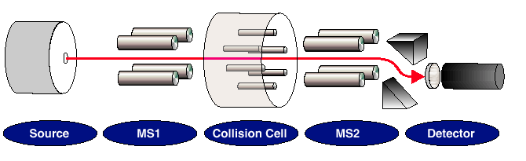

The Quattro Micro is often said to perform MSMS analysis because it has two separate analysers in the form of the MS1 and the MS2 quads. In MS mode only a single quadrupole is used to identify a compound according to mass. In MSMS modes we are using the first quadrupole to filter out a single mass, the gas cell to fragment the compound and the MS2 Quadrupole to filter out specific fragments. The advantage of using MSMS compared to MS is that it is more specific. Several different compounds may have a similar mass but only one compound has a specific mass and fragmentation pattern.

3.1 Quadrupole theory

When an ion moves through an electric field it is deflected by a force from its original trajectory. This effect is utilised in the Quattro Micro by using an electric field to deflect ions by mass. In a quadrupole there are four parallel, equidistant rods upon which are applied both a fixed (DC) voltage and an alternating (RF) Voltage. By controlling the field strength it is possible to filter through a single mass of ions. Yet, by ramping the field voltage and frequency we can pass progressively higher mass ions generating a mass spectrum. The relationship between the RF field strength of the quadrupoles and the mass of the ions transmitted is linear.
The field strength of the electric field given at specific point defined by the co-ordinates x and y is:
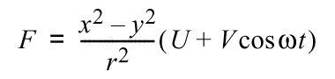
Where the field strength is F, r is the radius of the quad, U and V are fixed and RF voltages.
This implies that if X=Y then F=0.
The oscillatory nature of the field causes an ion trajectory to oscillate as it moves through the quadrupole assembly. Passage of an ion through the quadrupole assembly is referred to as stable motion, while ions that spin out and strike the poles is unstable motion.
Once the equations of motion are solved for the ions two factors emerge that are found to define the stable region of ion trajectory. These are defined as a and q, they are described by the following equations.
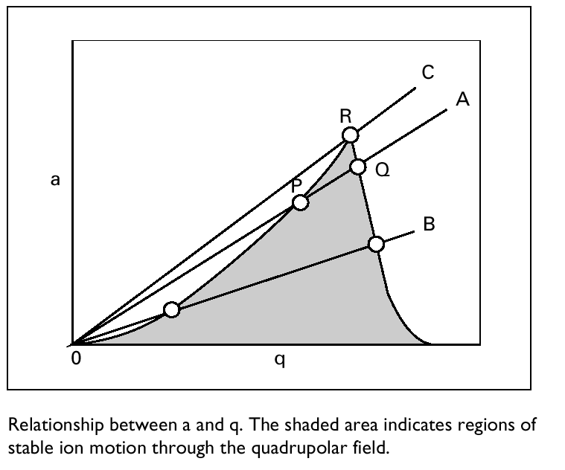
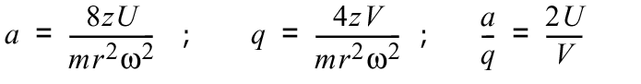
Where z = charge, V is the RF voltage, U is the DC voltage, r is the radius of the quad, m is mass and ω is the frequency of RF.
For small values of a and q, the shaded area in the graph below indicates an area of stable ion motion. Thus a line such as 0 to A with slope a/q defines a specific RF/DC ratio and shows the area of both a and q which gives stable trajectories.
Thus, the RF/DC ratio that is defined by the line 0 to C lets through only a single peak. Where as the line 0 to B gives a much larger transmission.
To ensure that only ions of any one selected m/z are transmitted the parameters should be chosen that will give an a/q line that will pass as close as possible to the point R, but still lies in the region of stability. For a given assembly r is fixed and electronically it is easier to change the ratio of U/V than it is to change the frequency to tune the instrument.
To scan a machine through a range of masses the frequency is kept fixed and the U/V is ramped linearly to allow through different masses. The specific crystal used on the A/D Main PCB decides the exact frequency of each machine. When in normal operation a triple quad has only one crystal working to power both quads, otherwise the two differing frequencies between the quads would kill sensitivity.
Although in theory hyperbolic quads are required to create ideal separation, circular quads are a good approximation when they are spaced properly.
Two opposite rods have a potential of + (U+Vcos ωt) and the other two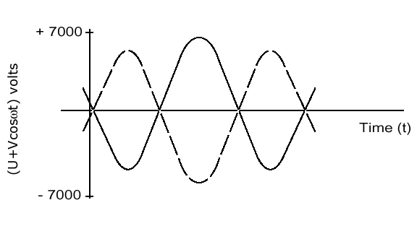 -(U+Vcos ωt) where U is the DC voltage and Vcos ωt represents the radio frequency of amplitude V and frequency Θ. It means that as the RF cycles with time the applied voltages on the opposed pairs of rods change as below.
The resultant electric field in the centre of the rods is zero when both DC’s are equal, i.e. if ion energy is zero.
In the transverse direction, along the quadrupoles, an ion will oscillate amongst the poles in a complex fashion depending on its mass, the voltages (U and V) and the RF frequency ω. By choosing suitable values of the above it is possible to get the ions to oscillate around the central axis; in this case they will oscillate in greater and greater amplitude until they strike a pole and become lost. However, because the quads have no actual potential difference down their length it is necessary to supply an acceleration voltage down the length of the instrument this is usually done by the MS1 pre-filter voltage. The pre-filter voltage is set to a constant 5V that changes polarity with ion modes.
Ions passing into the quadrupole assembly move along a stable trajectory if they are the “right mass”. Those that have an incorrect mass have unstable trajectory and oscillate out to hit the poles
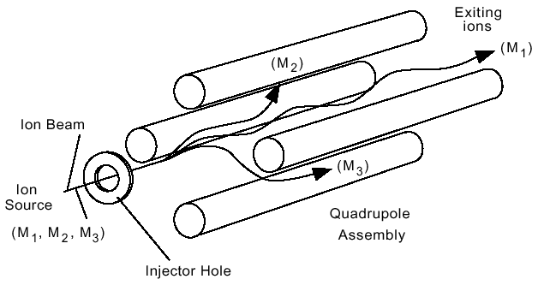

In practice the frequency (ω) is fixed, and the Quattro Micro uses a frequency of 832kHz, the DC Voltage (U) ramps from 0V at 2Da up to 500V at 2048Da. Very high accuracy is needed when the quads are assembled because inaccuracies will cause unparallel electric fields.
The nature of the electric separation of the quadrupoles means that any ions that are not being selected are spun out into the rods. Over time this will lead to the contamination of the rods as a surface builds up on them. The quads may need cleaning on an infrequent basis this process will be looked at later. Under no circumstances should the quadrupole assemblies be disassembled for cleaning, as they need to be to parallel to within several micrometers.

Prefilters - These look like little extensions to the quadrupoles and their sole job is to catch the Low Mass ions that rapidly spin out. It means that the pre-filters need to be cleaned rather than the quadrupoles to be cleaned.

3.2 Gas Cell

Between the MS1 and MS2 Quadrupoles is the Gas Cell or Collision Cell used in MSMS operation to fragment the chemicals traversing the analyser.
The Gas cell is an important component in the analyser that is used only in MSMS experiments. The gas cell is simply a hexapole, six metal rods that we apply RF to. At either end is a lens, the entrance at the front and the exit at the back, which are used to control the movement of the ions going through the gas cell.
In MS mode the gas cell is unused and high values are applied to the end lenses that accelerate the ions allowing them to pass through quickly. In MSMS mode these are set low to allow a longer passage through the gas cell and thus encourage a greater likelihood of fragmentation. In MSMS mode a small voltage may also be applied to the exit lens to ensure that the ions leave the gas cell after fragmentation.
The role of the gas cell is to fragment the ions that enter it in. To help with this we introduce argon gas to act as a collision molecule. Argon is chosen, it is dense, inert and monomolecular. The operator of the instrument should control the amount of argon gas in the gas cell as too much and multiple fragmentation may occur. Too little gas and the ion may pass through without colliding with an argon atom.
Also to help fragmentation there is a voltage applied to the gas cell called the collision energy. This is an acceleration voltage that attracts the ion into the gas cell and dictates the energy of a collision.
Thus when fragmentation occurs the ion breaks into two fragments, one with the charge the other will be neutral. The English technical names for this are parent ion for the initial ion, the products are the daughter ion and the neutral fragment.
American Nomenclature is non-Gender specific and uses the name precursor, product and neutral.
Occasionally multiple collisions occur and these ions are referred to as Grand Daughter ions.

3.3 MS Scanning Modes

The Quattro Micro uses a number of different scanning modes depending on the application that the user wants to run.

MS1 Mode: Sometimes referred to as MS mode. In MS1 mode the MS1 quadrupole is used to separate the ions traversing the analyser. The MS1 quad has both RF and DC that are both ramped to allow different masses to pass through over time. This allows the user to look at the spectrum of the original molecular ion. It can be used to create a spectrum in EI that can be compared with a library for chemical identification.
In MS1 Mode the MS2 quadrupole and gas cell run with RF only and transmit all the ions that pass through the MS1 quadrupole.
MS2 Mode: MS2 mode is not commonly used by customers In MS2 mode the MS2 quadrupole is used to separate the ions traversing the analyser. The MS2 quad has both RF and DC that are both ramped to allow different masses to pass through over time. This allows the user to look at the spectrum of the original molecular ion. Although is not generally used as it has slightly poorer resolution and sensitivity than MS1, engineers usually use this technique for diagnostic purposes.
In MS2 Mode the MS1 quadrupole and gas cell run with RF only and transmit all the ions that pass through the MS1 quadrupole into the MS2 quad.

SIR mode: SIR mode (sometimes called SIM) uses the MS1 Quadrupole as a mass filter and the RF and DC sit at a fixed value. This allows the Quattro Micro GC to monitor a single mass, increasing sensitivity and allowing for shorter scan times.
SIR mode only produces a chromatogram that can be used to calculate the amount of sample being injected into the GC by a technique known as quantitation.
In SIR mode the MS2 quadrupole and Collision Cell run with RF only and transmit all the ions that pass through the MS1 quadrupole.

3.3 MSMS Scanning Modes

As well as MS techniques the Quattro Micro can run a number of MSMS techniques that use the collision cell to fragment the ions that traverse the MS1 quad.

Daughter Mode - This technique is used to look at the daughter ions of a single parent ion. In this technique the MS1 quad is sat at a specific value of RF and DC to allow ions of that mass to pass through. The collision cell fragments the specific ion from the MS1 quadrupole. Finally the MS2 quad ramps both RF and DC to scan the daughter ions created. The spectrum produced can be used to identify the compound and the structure it possess.

Parent Mode - This technique is used to look at the parent ions that create a specific daughter ion. This is used to scan for families of compounds that fragment to create an identical daughter ion.
In this technique the MS1 quad ramps both RF and DC to pass different masses at different points in the scan. The collision cell fragments the ions from the MS1 quadrupole. Finally the MS2 quad acts as a specific mass filter as the RF and Dc are set at a specific voltage. This allows the detector to register when appropriate ions hit it and this can be directly related to when the ions pass through the MS1 quad.

Neutral Loss Mode - This technique is used to look at the parent ions that create a specific neutral molecule. This is used to scan for families of compounds that fragment to create an identical neutral molecule.
In this technique the MS1 quad ramps both RF and DC to pass different masses at different points in the scan. The collision cell fragments the ions from the MS1 quadrupole. Finally the MS2 quad ramps both RF and DC to scan the daughter ions created offset by the mass of the neutral molecule.

MRM mode - MRM mode is an extension of SIR mode except that both quadrupoles are set to a fixed mass, MS1 the parent mass and the MS2 the daughter ion. The ions are fragmented in the Collision cell between the quads.
Both quads in this technique are used as mass filters and this means that when an ion is detected it has the same mass and fragments in the same manner as the desired ion. This gives us a double check to the ion's identification.

