Second Midterm Exam
CMPSCI 591 and 453: Computer Networks
Spring 2005
Prof. Jim Kurose

ON AND OFF-CAMPUS STUDENTS ARE TAKING THE SAME EXAM

Instructions:

- Please use two exam blue books – answer questions 1, 2 in one book, and the remaining two questions in the second blue book.
- Put your name and student number on the exam books NOW!
- The exam is closed book.
- You have 85 minutes to complete the exam. Be a smart exam taker - if you get stuck on one problem go on to another problem. Also, don't waste your time giving irrelevant (or not requested) details.
- The total number of points for each question is given in parenthesis. There are 100 points total. An approximate amount of time that would be reasonable to spend on each question is also given; if you follow the suggested time guidelines, you should finish with 5 minutes to spare. The exam is 85 minutes long.
- Show all your work. Partial credit is possible for an answer, but only if you show the intermediate steps in obtaining the answer.
- Good luck.

Question 1: ``Quickies'' (27 points, 20 minutes)

Answer each of the following questions briefly, i.e., in at most a few sentences.

- What is meant by network-assisted congestion control? Give an example of a congestion control protocol that takes this approach. Does TCP take this approach? Explain your answer.
- What is meant by longest prefix matching? Why would a router use longest prefix matching in deciding how to forward a packet?
- We have said that BGP implements policy-based routing. What is meant by that? Name one path attribute that can be used by BGP in implementing policy-based routing.
- What is the purpose of the ARP protocol?
- Suppose one is interested in supporting real-time communication in a local area network, i.e., one is interested in bounding the amount of time it takes to send a packet from one host to another on the network. Would you recommend CSMA or token passing for such a network? Why?
- Suppose that Bob and Alice have access to a public key system that makes their public keys available to each other. Each know their own private key. Suppose Bob has a document, m, that he wants to digitally sign. How does he do so? Now suppose Bob sends the digitally-signed document to Alice. What specifically does he send to Alice? What steps does Alice perform to convince herself that Bob indeed signed the document?

Question 2: TCP (21 points, 20 minutes)

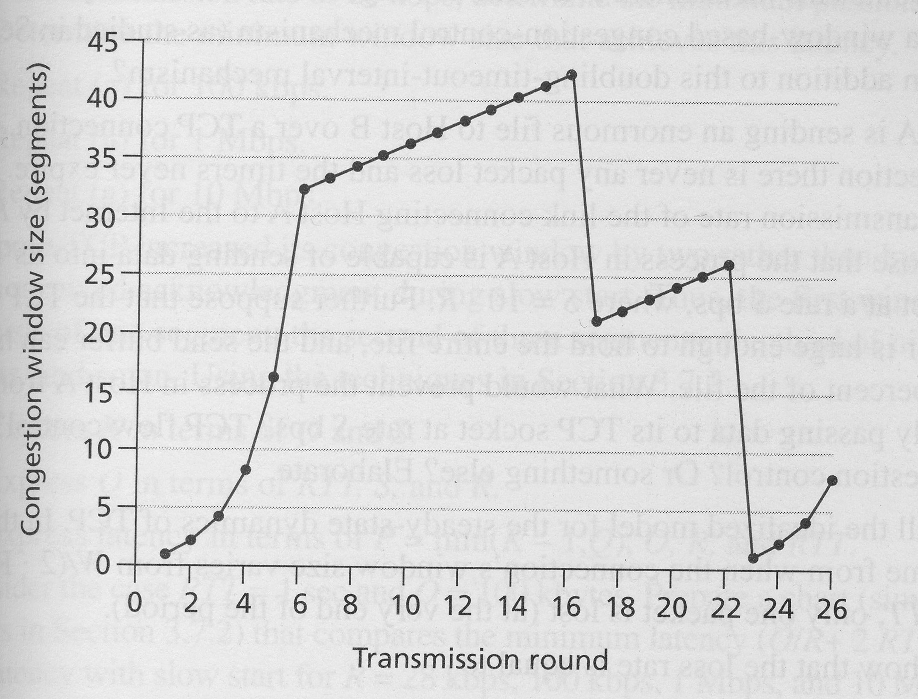
Consider the graph above, which shows the size of the TCP sender’s congestion control window as a function of time (transmission round) in an idealized timing scenario where the sender sends a window’s worth of packets and then receives ACKs (if any) at the end of the RTT. Answer the following questions:
- (2a) Why does the congestion window curve have one form from rounds 1 to 6, and then another form from rounds 6 through 16?
- (2b) What event occurs at t=16, given that the result of this event is the sender cutting its congestion control window in half.
- (2c) What event occurs at t=23, given that the result of this event is the sending cutting its congestion window to 1? How is this event different from that which happened at t=16?

Question 3: Routing Algorithms (26 points, 20 minutes)

Consider the network shown below.

- (3a) Show the operation of Dijkstra’s (Link State) algorithm for computing the least cost path from B to all destinations.
- (3b) Show the distance table that would be computed by the distance vector algorithm in B once the distance vector algorithm has finished executing. Note: you do not have to run the distance vector algorithm; you should be able to compute the table by inspection. Note: make sure you have a row in the distance table for each neigbor of B.
A
B
C
D
E
F
2
2
4
8
1
10
4
2
4

- (3c) Suppose now that reverse path forwarding is used to broadcast a packet from B to all other nodes. For nodes A, C, D, E, F indicate the neighboring nodes from which it will receive a copy of the RPF-broadcast packet and indicate which of these received copies it will forward on which outgoing links.

Problem 4: Addressing (26 points, 20 minutes)

.
(4a) Consider an Internet address of the form 128,119,40.0/23. What does the /23 signify?

(4b) Consider the network shown above, consisting of a single router, R1, with three subnets A, B and C, with 15, 12, and 45 hosts respectively on these subnets.

Assign an address range to the hosts in subnets A, B, and C such that only a single aggregated address need be advertised by R1 to the public Internet, and that the size of the aggregated address ranges that is advertised is minimized. In a ssentence or two, explain how yo arrived at your answer

(4c) Assign a specific Internet address and MAC address to the host shown in subnet A, an Internet address and MAC address to the host shown in subnet C, and a MAC address and IP address to each router interface. These addresses (both Internet and MAC) can be of your own choosing. Consider an IP packet sent from the host in Subnet A that is destined to the host in subnet C. This IP datagram is contained in an Ethernet frame sent from the host in subnet C to router R1. What are the source and destination MAC address of this Ethernet frame? What is the source and destination IP address in the IP datagram contained in this Ethernet frame?

(4d) Now consider the Ethernet frame carrying this IP datagram from the router to the host in subnet C. What are the source and destination MAC address of this Ethernet frame? What is the source and destination IP address in the IP datagram contained in this Ethernet frame?

