Windriver Software Setup Document

This document details the steps to be performed for building the Packet generator driver code using the Windriver software.

1. Install the board on the PCIe slot (x8 or x16).
2. Download the PCIe design and restart the machine.
3. Double click on the Driver Wizard icon and click on the ***Evaluate*** option.

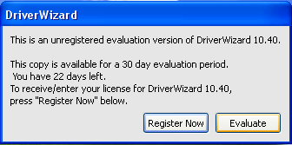

1. Click on the ***New host driver project*** option.

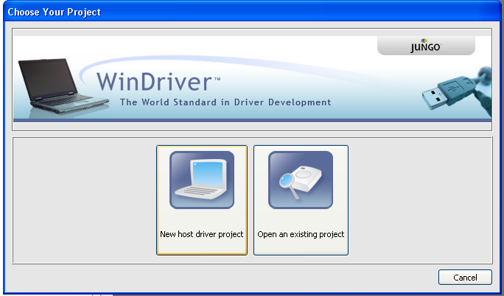

1. Select the Altera device from the list and click on ***Next*** option.

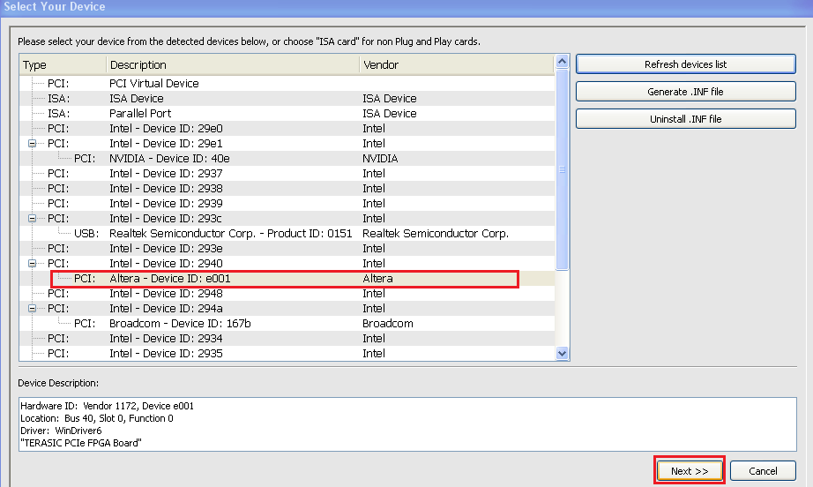

1. Click on the option highlighted in the figure below.

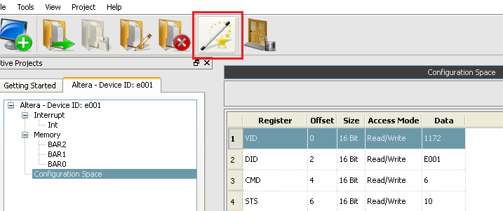

1. Select the required platform and click OK (I have selected MS Developer Studio 2010 for X86).

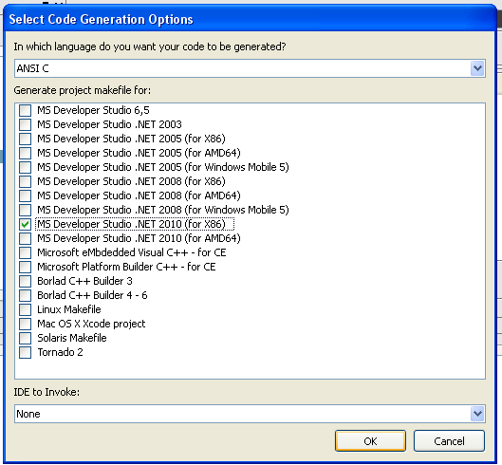

1. Click OK for the next option

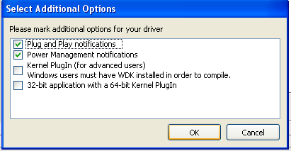

1. Save the project in the required folder with the file name ***pcie_sw***.

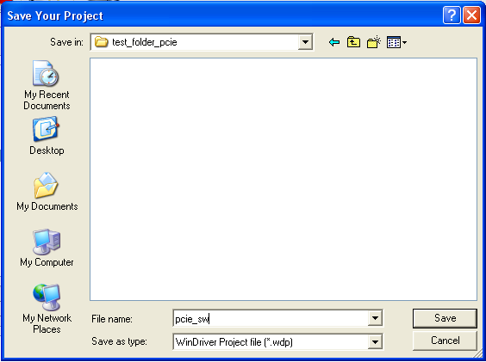

1. Click OK and close the driver wizard.
2. Open the project folder and copy the following four files to the ***root directory*** (*declare.h , pcie_sw_diag_packgen.cpp , reg_defines_packet_generator.h, altpcie_demo.cpp* ).

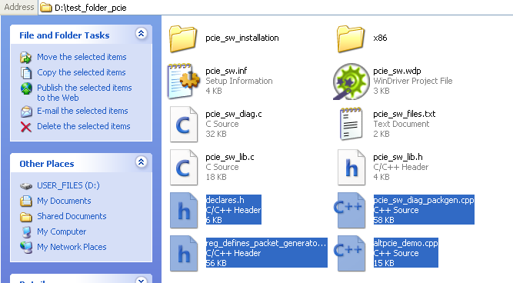

1. Copy these remaining files to ***root directory/x86/msdev_2010*** folder (*test.pcap, output.txt*).

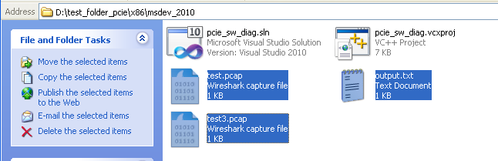

1. Double click on the ***pcie_sw_diag.sln*** to open the Visual studio 2010 project. The default file structure of Visual studio is shown below.

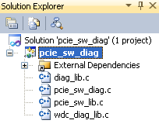

1. Right click and remove the ***pcie_sw_diag.c*** file from the file structure as shown below (This file has the default main program).

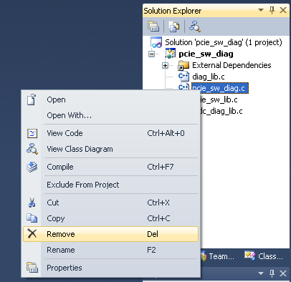

1. Add the four files from the root directory as shown below (***Right click pcie_sw_dag -> Add -> Existing Item)***.

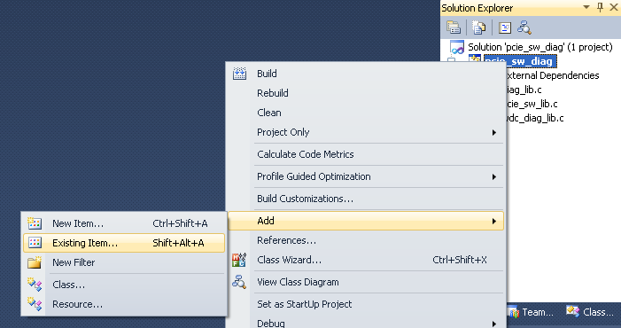

1. Select each of the four files from the root directory.

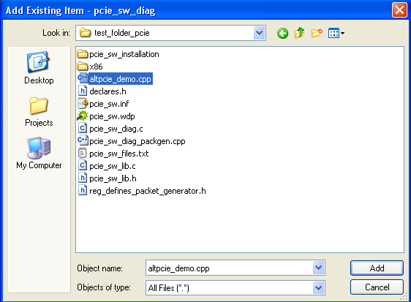

1. The file structure after adding the four files is shown below.

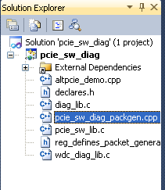

1. The following files (*altpcie_demo.cpp* and *pcie_sw_diag_packgen.cpp*) needs to be complied as C++ code. It can be done by

***Right click altpcie_demo.cpp/pcie_sw_diag_packgen.cpp -> Properties -> C/C++ -> Advanced -> Compile as C++ code***.

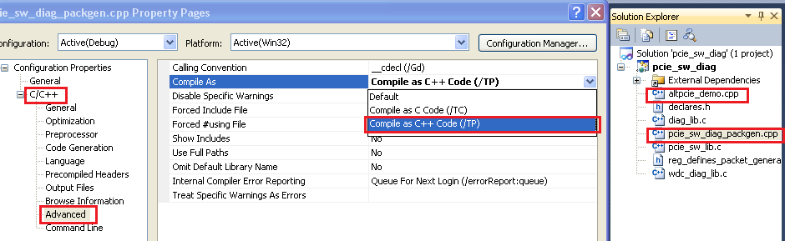

1. Now follow the remaining instructions in the user guide (setting up the pcap library) to get the PCIe packet generator working.