Theodore J. Floyd, EE, Dametreuss G. Francois, CSE, Jake R. Osborne, EE

Follow Me: Interactive Guidance Around Your Home

Abstract—Those with cognitive disabilities (dementia, Alzheimer’s, etc.) are faced with countless challenges every day, even in the comfort of their own homes. Often, the traditional American home is not equipped to support the lifestyle of one who is forgetting frequently. Follow Me is an easy-to-use tablet app which directs the user around the house with the push of a button. Follow Me takes note of the user’s starting position and lights a pathway to any selected room within the house, making finding the kitchen, bathroom, and exit as easy as ever.

INTRODUCTION
O
ur goal with Follow Me is to help extend the time in which the cognitively disabled can remain in the comfort and affordability of their own homes, while assisting unpaid caregivers in their noble efforts.

Significance
Approximately 5.8 million Americans in 2019 are living with Alzheimer’s disease, with that number expected to increase to 13.8 million by 2050. And eighty-three percent of care for those afflicted are cared for by a family member or other unpaid caregiver. [1]

Context and Existing Products
Cognitive disabilities are traceable back to hundreds of years ago, and still today there are no cures but there are treatments. Our project mixes treatment with therapy, since it trains the brain of the user. However, there are other products either existing or in development which help guide people around an indoor environment. For example, in Massachusetts an unnamed project was recently approved by the state fire marshall which directs occupants of a building to the optimal escape route in the event of a fire. This product is incredibly innovative, but it differs from our design in the sense that it takes no input from the user and is only present in a disaster scenario.

Another similar product is NavCog [4] which was developed by a research group working in the Cognitive Assistance Lab at Carnegie Mellon University. The goal of NavCog was to provide an indoor navigation aid for the blind. Their implementation included placing many Bluetooth Low Energy (BLE) Beacons throughout a building. The information from the beacons allowed them to triangulate the position of the person holding the phone running their application. The application would then talk the person through the path. With our design, we want the guiding path to persist outside of the device instead. We would also like to use something cheaper and less obtrusive than the large amount of BLE Beacons required for NavCog.

Societal Impacts
Care at this level can be incredibly taxing, and professional care is quite expensive, leaving countless families between a steep bill and a sleepless schedule. In fact, in 2019 the average monthly cost of nursing homes rose to $7,441 for a semi-private room, and $8,365 for a private room [2]. If our project can help keep caregivers and their loved ones out of a home, safely of course, for just one month then that family will have saved thousands.

We also see potential applications in disabled children as well. Often young children with down syndrome, autism, or other conditions which affect comprehension visit the homes of social workers. Training them to navigate these new places could prove extremely beneficial long-term. Our project shares likeness to a very basic video game. As the correct route is taken lights are extinguished and the next step is illuminated, and video games (even as basic as this) have proven to increase grey matter in the brain, combatting the effects of aging, even Alzheimer’s. [3]

Requirements Analysis and Specifications
Our project will be mobile, (using wireless communication) responsive (with a fast response time), and comprehensible (by using a dementia-friendly android app). See Table 1
Requirement | Specification | Value
Wireless Communication | RFID Range | 1-3ft
 | Bluetooth Range | >35ft
Responsiveness | Response Time | <.95s
Comprehensible | Dementia Friendly | -
Table 1: Requirements and Specifications

Design

Overview
Our team approached this problem in a way that we thought would provide the most user-friendly experience. This design includes a user interface, a central processing unit, a means of indoor tracking, and controllable light fixtures placed near doorways. See Figure 1

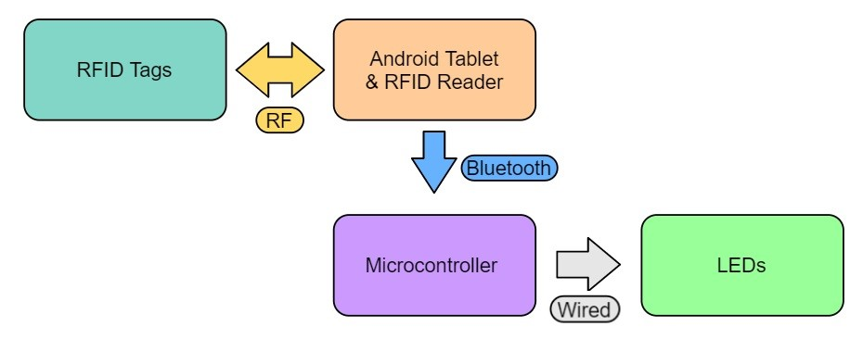
Figure 1: Block Diagram
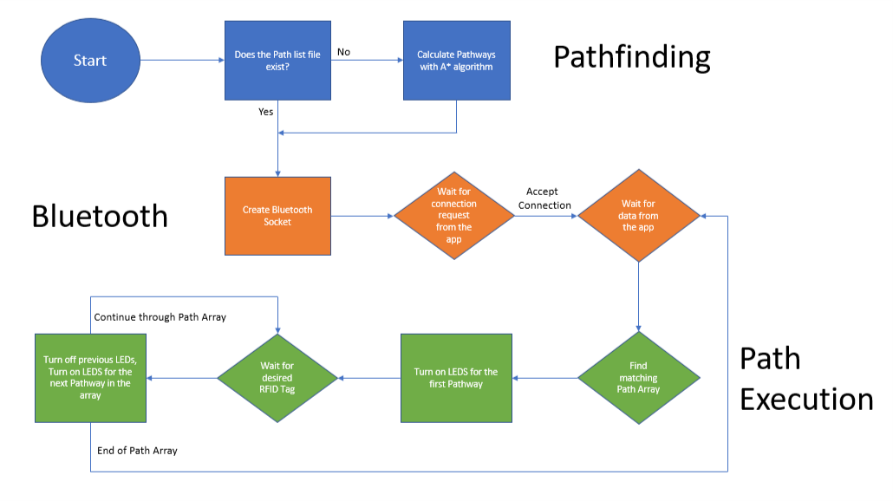
The indoor tracking will use RFID (Radio Frequency Identification) tags mounted within the home to trigger a data response from an RFID reader [6], tracking the user’s location within the home. The user will select their desired destination on an android tablet [7], and then based on the selected end point and current start point a pathway will be illuminated. This data processing will occur within a Raspberry Pi central processing unit [5]. As the user passes by the lit LED strip, or gateway, (as tracked by the RFID reader) the passed light will turn off and the next gateway will light up, guiding the user around their home.

RFID Tags
The RFID tags will be written to by the RFID reader and given a specific signature. These signatures will be used to create virtual checkpoints that track the user around their environment.

Tablet & RFID Reader
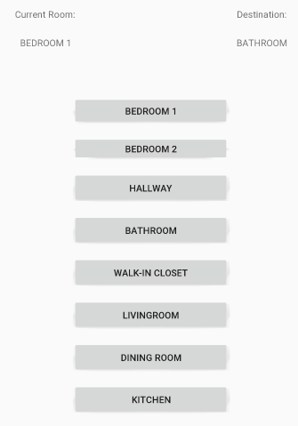
The tablet will be running an Android application which requires writing mostly in Java. To achieve the desired functionality of communication between the tablet and the microcontroller, this app will need to be able to create and accept Bluetooth socket connections. We will also need to utilize the RFID Reader API so that the tablet can properly
Figure 2: Interface Screenshot (mark 1)

receive and interpret the data when the device detects an RFID tag. This can all be tested by writing code that displays data that has been received from both the microcontroller and the RFID reader as strings and ensuring the data is accurate/expected. We would also need to have code running on the microcontroller that can display received Bluetooth data to ensure the tablet is sending what we expect it to. As for the design of the tablet’s interface, we plan to incorporate what is referred to as “Dementia Friendly” design principles to make the user experience as smooth as possible for our target demographic. Some examples of these design principles are high contrast, outlines, and displaying words with a visual representation of their meaning.

Microcontroller (Raspberry Pi)
A Raspberry Pi 3B [5] will be used as the controller in our project. This controller will be the center of our project and will handle communications to the tablet, decide which pathways need to be illuminated, and take input from the RFID reader to determine location. The controller is programmed in Raspbian and uses arrays in order to determine the pathways to get a user from point A to point B. Along with this, the raspberry pi controller is optimal for our system as it has multiple i/o pins which allows for larger homes to be implemented into our solution. The software flow diagram below details how our code will be executed within the raspberry pi.
Figure 3: Software Flow Diagram

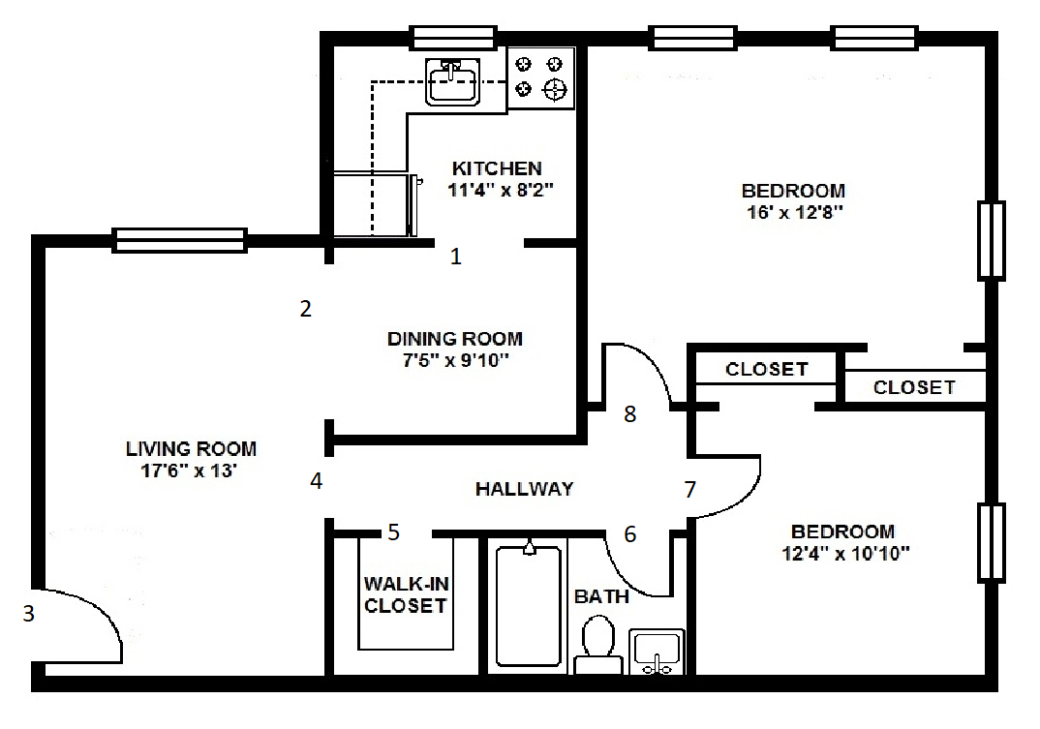
LEDs/Model Home
Figure 4: Model Home Floor Plan. Note that the numerical labels (1-8) indicate the archways to be lit up.

A model home has been constructed and sponsored by Blackstone Valley Technical High School in Upton, MA which our team will use to demonstrate the functionality of the project. The house is representative of a traditional one-story floor plan common to the elderly. This house is exclusively for demonstration of the pathways and will be wired with LED strips in the numbered archways.

Project Management
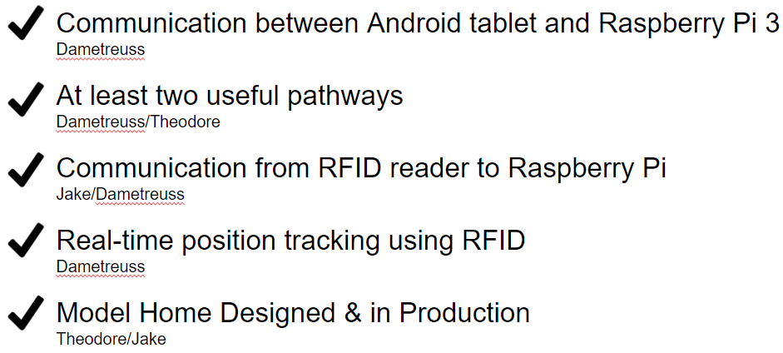
Our team accomplished every MDR goal we set after PDR. The figure below details all that we accomplished by our demonstration on December 13th, 2019.
Figure 5: MDR Deliverables

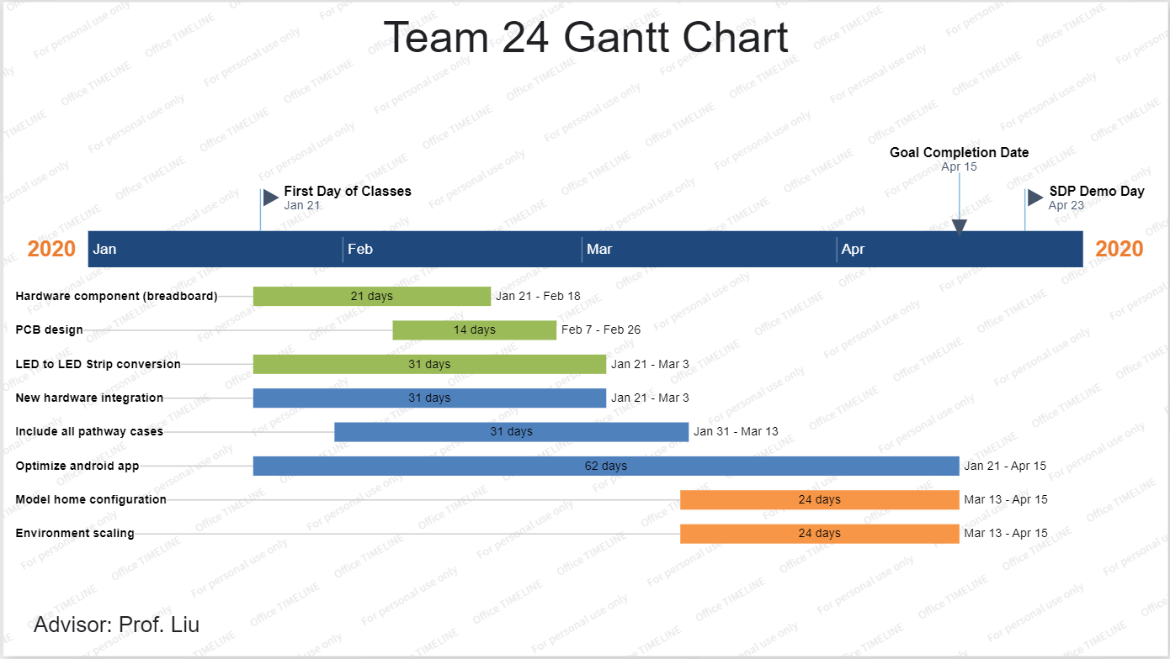
Next semester, our team will set out to complete our hardware component (power circuit for the LED strips) on a breadboard, then print a custom PCB to house our design. Once this circuit is fully operational, we will fully migrate away from ordinary LEDs. Meanwhile, on the software side, we will program all remaining pathway cases within our house model, integrate our new RFID reader, and spend background time optimizing the android app so that it is more dementia friendly. Once the app and hardware are fully complete, we will install our project into the model home, and scale our project up virtually to prove that it can be applied to a full-sized home. These upcoming steps are shown in Figure 6 on our team’s Gantt chart.

Figure 6: Gantt Chart

Conclusion
As of MDR, we have a fully functioning prototype for all divisions of our project: interface, processor, RFID reader, and LEDs. The project can take destination input from the tablet and display the correct pathway on the breadboard, with each LED functioning properly. In the event that the wrong RFID tag is presented, simulating an incorrect gateway has been crossed, the processor is able to recognize this and send an error message. This is the exact position we wanted to be in by MDR, and our next steps are to make the project more mobile and begin scaling for a larger environment.

This will include integrating a new RFID reader, one which is more mobile and can be attached to the tablet and integrating the reader with the code written for the tablet app as well. Meanwhile we will design and print the power circuit that will drive our lights as we migrate from LED’s to LED strips. The android app will also continue to be refined as we continue our research into dementia friendly presentation. Ultimately, we hope to have a redesigned interface, a mobile reader, and new display lights but all with the same general functionality of our MDR prototype.

Since we have not yet chosen a specific RFID reader, we anticipate that the integration of a new device into our existing system will be the biggest challenge. But our experience thus far should prove valuable when transferring data from the reader to the CPU.

Acknowledgment
Our group would like to thank our advisor, Professor Tongping Liu for his guidance throughout our project. We would also like to thank Michael Norton and the Blackstone Valley Technical High School team who constructed the model home for our project, bringing our design to life. Lastly, we would like to thank Fran Caron, Professor Hollot, and Professor Goeckel, who all lent us advice that was instrumental in the success of our project.

References
- “Facts and Figures.” Alzheimer's Disease and Dementia, 2019, www.alz.org/alzheimers-dementia/facts-figures.
- “Nursing Home Costs in 2019 by State and Type of Care.” SeniorLiving.org, 22 June 2019, www.seniorliving.org/nursing-homes/costs/.
- Rense, Sarah. “Playing Video Games Could Help Prevent Alzheimer's.” Esquire, Esquire, 5 Nov. 2018, www.esquire.com/lifestyle/health/a14379049/video-games-prevent-alzheimers/.
- Ahmetovic, Dragan, et al. NavCog: A Navigational Cognitive Assistant for the Blind. Carnegie Melon University, 2018, pp. 1–9, NavCog: A Navigational Cognitive Assistant for the Blind.
- “Buy a Raspberry Pi 3 Model B – Raspberry Pi,” Buy a Raspberry Pi 3 Model B – Raspberry Pi. [Online]. Available: https://www.raspberrypi.org/products/raspberry-pi-3-model-b-plus/. [Accessed: 28-Jan-2020].
- RFID Reader/Writer Module for Arduino, vetco.net/products/rfid-reader-writer-module-for-arduino?gclid=CjwKCAiA1L_xBRA2EiwAgcLKA_hYrtFlYZ5E14B1d6PTxIvMZbfMbE9heK3XuHQhrdr7bM1Dx1dBORoCaV8QAvD_BwE.
- Android Tablet 10 Inch, 5G WiFi Tablet, 16 GB Storage, Google Certified, Android 8.1 Go, Dual Camera, Bluetooth, GPS – Black.” Amazon, www.amazon.com/Android-Tablet-Storage-Certified-Bluetooth/dp/B07SZDQG1S/ref=sr_1_7?crid=2B122WPKIE1I&keywords=10in tablet&qid=1580251616&sprefix=tablet with 10in,aps,155&sr=8-7.

Appendix

Design Alternatives
Our project has held the same design since for the entirety of the fall semester in every regard but one, indoor tracking. We had originally planned on using motion sensors mounted in the archways but due to cost and functionality issues presented by Professor Wolf in our PDR we had to move on. We were worried that motion detection was too broad, and it would require that the user be the only person in the area. We then planned for the use of three Bluetooth beacons to triangulate location throughout the home but decide that the software burden would be too great given our already heavy load on our software development team. Finally, after seeking advice from Professor Goeckel (who has advised indoor tracking projects in the past) we landed on our final design of RFID indoor tracking.

Testing Methods
Since our goal for MDR was the functionality and intercommunication of each component of our project, there has been quantitative testing. Instead we focused much of our efforts on qualitative testing. Our first test was the Bluetooth communication between the tablet and Raspberry Pi. After the app was designed, we sent strings of input data from the tablet to the pi in long sequences (25 instructions long) and then displayed the data being received. Fortunately, the input data matched the displayed data in all five of our trials, so we confidently moved on from the Bluetooth connectivity to the RFID communication. After writing to each of our 8 tags we performed a similar experiment to the Bluetooth testing, where long patterns of RFID tags were read by the reader, and then displayed to match the same order. We ran into some issues where the reader would not notice the tags at all as we edited our code, but soon came to the realization that we were not in the same mode for both Bluetooth and RFID. Dametreuss quickly corrected this and our project began transferring and processing all data effectively. We also tested our programmed pathways and current room tracking by altering selecting the same destination from multiple starting points. Finally, we measured the maximum distance our tablet could be from the CPU and were pleased to find that our devices could communicate from over 40ft away.

Next semester, in order to hit all of our specifications we will need to clock the processing time of our software from user input to power output. We plan to do this by writing a timing algorithm in our software triggered by the input data and halted by the output.

Team Organization
Our team is organized and extremely efficient, using our smaller size as an asset rather than a hinderance. With a group of three instead of the traditional four-person group, we have more on our individual plates, but we are also able to come to agreements and make decisions at a very high rate. Theodore is the team manager and has been instrumental in the communication and presentation of our project, while also taking on the PCBA design given his hardware experience. Dametreuss is the software lead, and has demonstrated an incredible ability to explain his code to the rest of the team so that they my understand and contribute to the software portion of Follow Me. Jake is a jack of all trades, he works along with Theodore on the hardware integration, while also assisting with software and conducting all budgeting/purchasing.

Since our MDR prototype was focused around functioning software, our group has been largely focused on supporting Dametreuss. Jake helped get the RFID reader communicating with the Raspberry Pi, and Theodore plotted and wrote the code for the pathways around the home with guidance from Dametreuss. We have been lucky enough to have no communication issues so far; in fact, communication and collaboration may be our strongest asset, likely due to our smaller size. Each group member has enough work to feel motivated, and this project is near and dear to all of our hearts.

Beyond the Classroom
Theodore: So far, I have had the privilege of acting as team manager to a group that is cooperative, hardworking, and driven, so my leadership skills have really taken a back seat. Instead, I have developed my listening skills. Dametreuss and Jake have worked together in the past, but as their new team member I have had much to learn from them. They have both been excellent resources to me, and I feel confident that I will take with me some of the perseverance they have brought to our team. I see a direct relation between this team and my professionally career going forward. As someone comfortable in a leadership role I have learned to open my ears and mind more to the ideas and suggestions of other, a skill which has helped our project come together smoothly and efficiently.

Dametreuss: Most of the programming I’ve done for this project so far has involved/required learning, implementing, or working with something that I had little or no prior experience with. Some of the things I’ve learned so far include creating/utilizing Bluetooth connections between programs and devices, using an RFID Reader and integrating it into a program, programming in Python, and developing an android application. Being able to have one project that connects so many different areas of software development serves as a great way to build up my skill set for the future.

Jake: Throughout this semester working with my group members I have definitely learned a lot, but I think mostly I have learned how to incorporate everyone's ideas into a single project. Our team has different ideas and solutions from member to member, but all have one common goal in mind. Due to this I have learned and developed a way of reasoning and evaluating ideas such that the common goal as well as the team itself is satisfied. Going forward into my professional life I see this being very useful as teams are a large part of engineering and knowing how to reach the common goal with many inputs from members is going to be extremely important.

T. J. Floyd, Upton, Ma (e-mail: tfloyd@umass.edu). D. G. Francois, Harmony, Fl (e-mail: dfrancois@umass.edu). J. R. Osborne from Blackstone, Ma (e-mail: jrosborne@umass.edu).

