Richard W. Brown, EE, Titus Rwantare, CSE, Cormac Kennedy, EE, and Ibrahim Tahoun, CSE

Team 1 MDR Report

Abstract—At one point, we’ve all felt the pain and frustration of losing a valuable personal item. The Radius Bluetooth tracking system is a solution that not only enables you to find your possessions at the push of a button, but also prevents losing them in the first place. Consisting of a Bluetooth tracking tag and an Android application, Radius establishes a perimeter around you and your devices and alerts you when paired devices exceed an allowable range, drastically reducing the amount of time and money it takes to find or replace lost items. Radius doesn’t just solve the lost item problem; it removes the problem entirely.

INTRODUCTION
Recovering a misplaced personal item can be extremely resource intensive. Whether you are wasting time looking for a lost item, or spending hard-earned money to replace it, we can all agree that the situation could be improved if the item had not been misplaced in the first place. The Radius Bluetooth tracking system prevents lost items by providing real time alerts via an Android application and Bluetooth tracking tag when an item is at risk of being left behind.

Significance
People all over the world lose things every single day, and as the pace of our lives continues to increase, so does the number of lost items we experience. James Gleick writes in his book Faster, “We are spending about 16 minutes of each day looking for misplaced items which is almost a year of our entire life searching for lost possessions,” [1]. According to the United States census bureau, the median annual income of a United States citizen is $31,177 [2]. This means that an average American has the potential to lose over $30,000 worth of time looking for lost items, and this figure is not even factoring in the cost of replacing lost items.

Context and Existing Products
There are many Bluetooth tracking technologies available on the market, the most successful being the Tile Bluetooth tracker. The Tile tracking system consists of a Bluetooth tracking tag, and mobile phone application. By attaching a Tile tracking tag to an item, you can find it by sound, or by seeing its last known location on a map [9]. Another prominent Bluetooth tracking company is Chipolo, which offers the exact same exact functionality as Tile in a different aesthetic [10]. Both companies allow you to find your lost items, but neither of them prevents losing an item in the first place. Our Bluetooth tracking system not only provides the same functionalities of Chipolo and Tile but goes one step further to prevent losing an item before it can be left behind. By constantly checking to make sure you have not been separated from your items, our tracking system is able to inform the user in real-time that they are about to lose an item in order to avoid the need to look for it at all.

Societal Impacts
Everyone has experienced losing an item, whether it is a mother who has lost her child in a grocery store, or a college student who has lost their cellphone in their dorm room; it is rare to find a person who would not admit to losing a prized possession. Since the problem is so widespread, the solution should be accessible to everyone. Accessibility plays a huge role in how our product is designed and implemented. A convenient Android application allows anyone with a smartphone to download the application, and anyone with more than twenty dollars the opportunity to never lose a personal item. The goal of Radius is just that, to give everyone the opportunity to keep what they value, in a way that economic, convenient, and accessible.

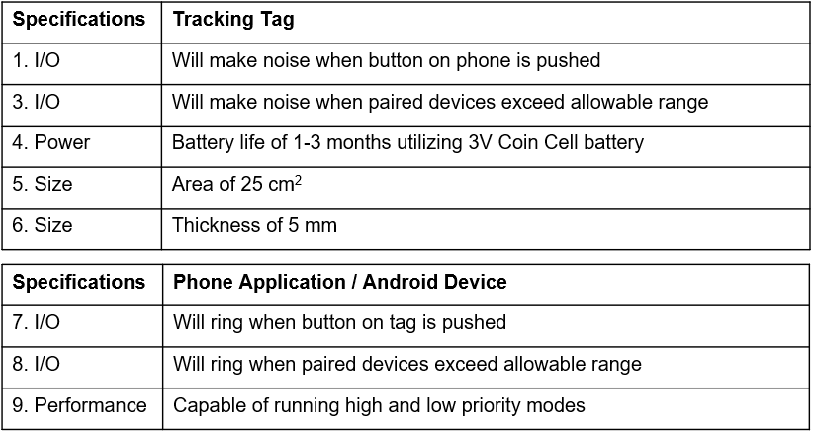
Requirements Analysis and Specifications

Figure 1: Requirements and Specifications
Requirements and specifications for our final product were based off our current development board and other competitor products. The size of the tag being set to 50x50mm is approximately half the size of a credit card, allowing for seamless placement inside a wallet, keychain, or attached to an electronic device (phone, tablet, laptop). This size makes our design comparable in size to existing products. The thickness of the board is governed by our thickest component, the battery. 5mm will allow us to contain a CR2032 3V coin cell.
Our power specification was calculated by analyzing the CR2032 coin cell battery along with the EFR32MG12 development board’s power consumption while running and in sleep mode. The board supports supply voltages above 3V, down to a 3dB point at 2.12V. Using the datasheet, we computed testing values using the provided data given 2 modes of operation – continuous draw and periodic pulsing. We calculated, using a 15kΩ load and a typical draw of .19mA at 2.9V in room temperature, the board will drain to the 3dB point after 52 days (1.5 months). By altering our active/sleep duty cycles to represent high (0.1Hz) or low (0.03Hz) priority items based on user preference, the battery should conservatively last 1 month or 3 months respectively.
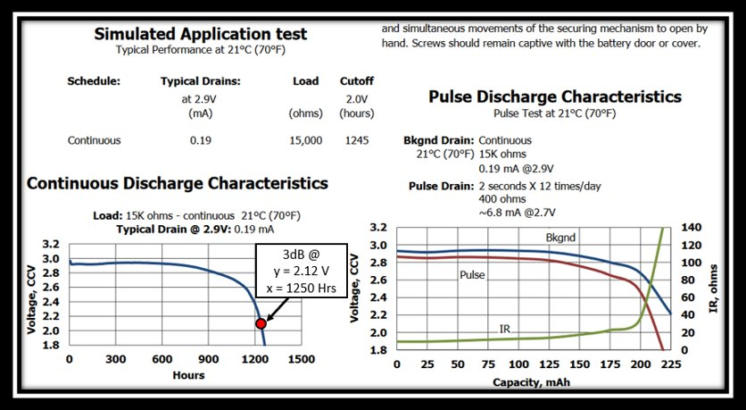
Figure 2: Power Consumption calculations
Sound produced by the tag will be produced using a piezo buzzer attached to its I/O when triggered by the application on the user’s phone. Likewise, a button mounted on the board will cause the phone to ring if the user would like to locate it, or when a tag is out of range.

Design

Overview
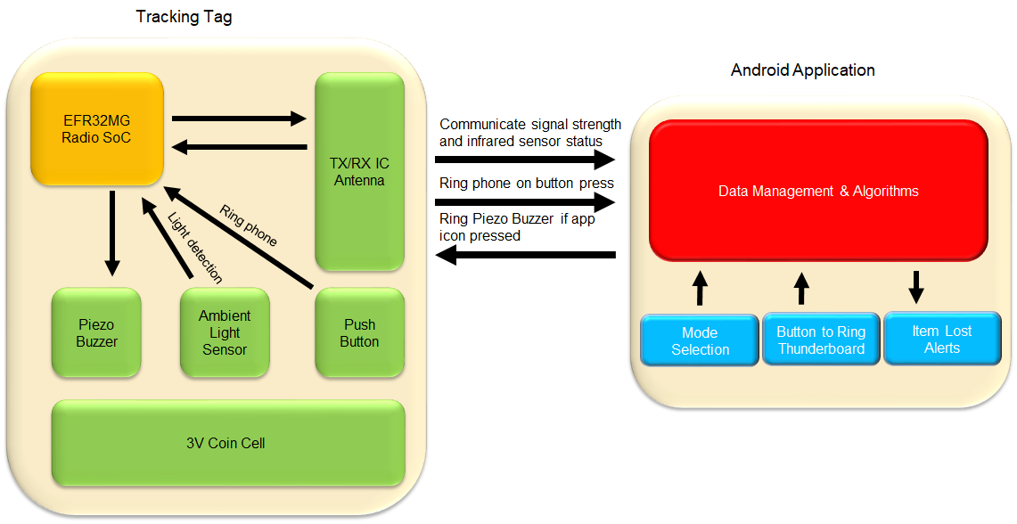
To create a tag that helps people keep their items, we felt that we needed it to be small and require minimal maintenance. To achieve this goal, we selected the Bluetooth Low Energy (BLE) protocol. BLE allows us to build small and power-efficient tags. The presence of Bluetooth antennas in modern smartphones decreases the need for one piece of hardware (anchor node). We only intend to make one tracking tag (tag node) and have it interface with the Bluetooth system already in smartphones. While we considered some sort of phone attachment for a user’s smart phone to enable technologies like Wi-Fi, Ultra-Wideband (UWB), and RFID, we decided that the increased hardware size and costs associated with a phone attachment would not be a trade-off consumers would be willing to make. The benefits and shortcomings of these technologies are further discussed in Appendix Section A. The balance between size, cost, power-draw, availability, and performance was the basis of our decision.
Figure 3: System Block Diagram
The components represented in our block diagram in Figure 3, are what will be sufficient to create our basic loss prevention system capable of warning users when they are move 5 meters away from the tracking tag (or from the phone with the tracking tag on their person). There may be more components added to the application and board design if our testing deems it to be necessary.

Block 1: Tracking Tag
The tracking tag will contain the components needed to power itself and communicate with a user's devices. Most of the complexity of the tag revolves around operating the EFR32 SoC. This SoC contains the Bluetooth radio whose transmissions’ RSSI (Received Signal Strength Indicator) is measured by the phone. This measurement is then input into the logic of the Android application. The Android application uses the RSSI to estimate the proximity of the tracking tag to the Android device.
The RSSI is a measure of the power level of the signal transmitted by the tracking tag as detected at the Android device. A strong Received Signal Strength Indicator (RSSI) means the Android device and tracking tag are in close proximity, while a weak RSSI is indicative of a greater distance between phone and tracking tag. Additionally, the SoC will be programmed to emit an alarm when the signal to the phone is lost, and when the user is manually trying to locate the tracking tag. Messages transmitted from the phone to the tracking tag will enable the CPE-120 piezo-electric buzzer [7] to create an audible noise that will help to inform the user of the tracking tags location. The PCB will also have a ceramic antenna to transmit the Bluetooth signal to usable ranges.
The tracking tag will be powered by a CR2032 3V coin cell. This battery was selected in order to produce a sleek PCB design whilst also providing enough capacity to be able to satisfy the power specification described in Figure 1 (Specification #4). The CR2032, along with the coin cell mount will be the thickest component on our PCB and has been measured to be under 5mm in thickness, which satisfies the thickness specification in section 1, part D of this report (Specification #6).
We opted to alert the user with a CPE-120 piezoelectric buzzer due to the compact size and adequate volume [7]. The buzzer will produce noise if a user explicitly triggers an alert in order to find the item the tag is attached to. Additionally, the tag will emit noise when the connected smartphone goes out of range. The piezo-electric buzzer will be powered by a 3 Volt, 5 kHz square wave that will be produced by the EFR32 [6].
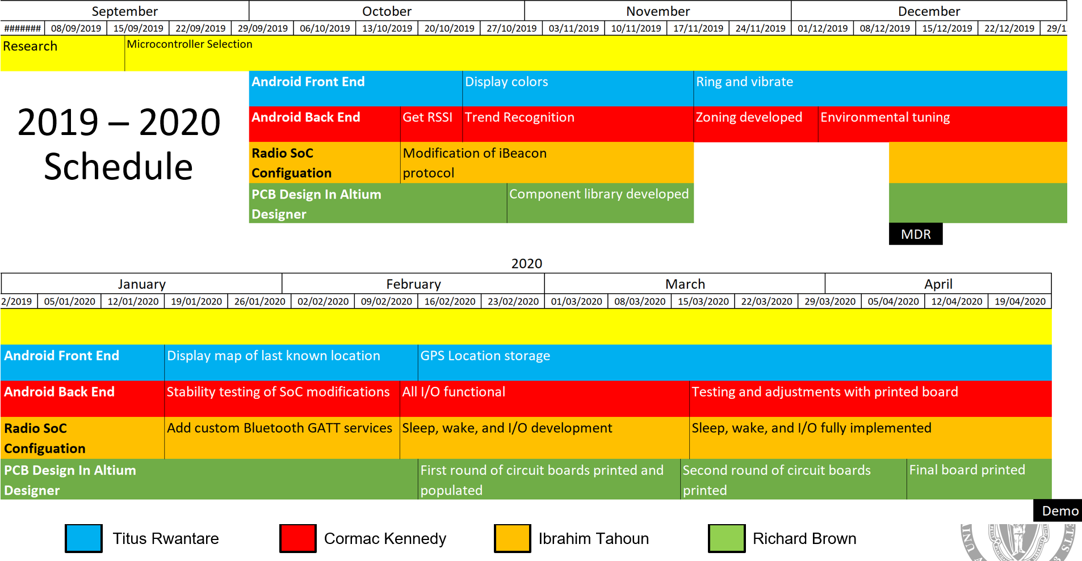
Our PCB will utilize an APDS-9007-020 Ambient Light Sensor which will allow the tracking tag to be able to detect if the tagged object is enclosed in a bag or pocket [8]. The state of being enclosed will result in more frequent signal transmissions, allowing for better system performance with an attenuated signal. For example, if the amount of ambient light sensed by the tag is below a certain threshold, we assume that the tag is being enclosed in a pocket or bag, and that the sensitivity of the application needs to be adjusted to account for the signal attenuation caused by this situation.
Figure 4: Gantt chart - BLUE: Titus Rwantare RED: Cormac Kennedy ORANGE: Ibrahim Tahoun GREEN: Richard Brown
A push button on the tracking tag will provide a manual input source on the tag. This input will be used to ring the smartphone if a user wants to locate their phone using the tag. To create a robust tracking tag, the testcases we have considered so far are described in Appendix Section B. The testcases will be key in tuning the behavior of our software in situations where there are obstacles impeding the signal, even though the tagged item is not lost.

Block 2: Android Application
The Android application is a crucial component of our setup because it allows the user to interface with the tags. The application will enable the user to ring the tag and allow the phone to be rung by the tag manually. The application hosts the algorithm that also enables the phone and tag to ring automatically when they are far apart, the threshold for this automatic warning will be configurable by the user, they will have the choice between high and low priority items, with higher priority items resulting in an alert at a smaller radius of separation.
To reduce the probability of the phone ringing when the tag is close proximity but with an attenuated signal, the algorithm we’ve written maintains a short-term trend monitor. Monitoring the trend allows us to determine if the tag gradually got out of range - alert for this, or the tag suddenly went out of range – do not alert for this. In the latter case we assume that a signal blocking obstacle is suddenly introduced, and the tag is still in proximity.
The Android application is built with the Java programming language and utilizes the Android Bluetooth library [11] to interface with the phone’s built-in Bluetooth radio and communicate with the external tag. We utilize this connection to transmit the alert state determined by the software logic to the external tag.
Finally, the app uses the Android location library to log the GPS location at which a tag’s signal was lost, in case the user had disabled or ignored the automatic alerting.

Project Management

Figure 2 illustrates our projected specification requirements for our final project. Our goals for MDR were accomplished, but minor alterations to our goals were made at the start of the project. Our first approach was to distribute responsibilities to each team member, but later decided on appointing leaders for each aspect of the project, allowing for overlapping efforts. Our main goal for MDR was to produce a successful prototype capable of handling transmissions from the tag to the phone, which was predominantly software based. Although we have made progress on the development board, next semester will be aimed towards hardware design. Specifications 4, 6, 7, 8, 9 from Figure 2 have been satisfied as required for MDR.
Figure 3 is a Gantt chart that displays the responsibilities for each team member in the first semester.
Refer to Appendix C to see examples of our team structure and approach to the project, as well as examples of leadership and initiative taken by each team member.

Conclusion
Our project currently consists of a functioning Android application that can approximate the proximity of paired devices. The Android application consists of a simple user interface that informs the user if an item is about to be left behind. Our team collaborated to determine the best way to approximate proximity from the RSSI (Received Signal Strength Indicator) signal and tried two different approaches for implementation. The zone-based tracking algorithm uses empirical measurements to categorize the RSSI signal into three different zones that represent an item being close, moving away from the user, and being completely lost. The second approach utilizes state-based tracking to determine proximity based on the observation of the history and trends of the RSSI signal that has been collected during program execution.
The next step in our development process will focus on two-way communication from the Android application to the Bluetooth module to provide interrupts for ringing the piezo buzzer on the tracking tag. We are aiming to have our localization technique finalized at the start of the Spring semester, then promptly begin PCB design.

Acknowledgment
Team 1 would like to acknowledge Professor Aksamija for providing wisdom and support both while selecting a project and during design and implementation phases. We would also like to thank Professor Hollot for organizing bench side meetings and providing feedback on our progress. Finally, we’d also like to thank Professor Burleson and Professor Kwon for evaluating the progress that has been made so far.

References
- J. Gleick, Faster: the acceleration of just about everything. London: Abacus, 2011.
- “U.S. Census Bureau QuickFacts: United States,” Census Bureau QuickFacts. [Online]. Available: https://www.census.gov/quickfacts/fact/table/US/SEX255218. [Accessed: 05-Dec-2019].
- R. Balani, ‘Energy Consumption Analysis for Bluetooth, Wi-Fi and Cellular Networks’, Research Paper, University of California at Los Angeles, Los Angeles, n.d.
- P. Prasad, ‘BLE vs Wi-Fi: Which is Better for IoT Product Development?’, Cabot, 01-Feb-2018.
- A. Alarifi et al., ‘Ultra Wideband Indoor Positioning Technologies: Analysis and Recent Advances’, Sensors (Basel), vol. 16, no. 5, May 2016.
- ‘EFR32MG1 Mighty Gecko Multi-Protocol SoC Family Data Sheet’. Silicon Labs, 2016.URL: https://www.silabs.com/documents/public/data-sheets/efr32mg1-datasheet.pdf
- ‘CPE-120 Datasheet’. CUI Inc, 07-Dec-2007. URL: https://www.cuidevices.com/product/resource/cpe-120.pdf
- “APDS-9007-020,” DigiKey. [Online]. Available: https://www.digikey.com/product-detail/en/broadcom-limited/APDS-9007-020/516-1719-2-ND/1785429. [Accessed: 23-Jan-2020].
- “Find Your Keys, Wallet & Phone with Tile's App and Bluetooth Tracker Device,” Tile. [Online]. Available: https://www.thetileapp.com/ [Accessed: 23-Jan-2020].
- “Find Your Keys, Wallet or Anything You Don't Want to Lose,” Chipolo. [Online]. Available: https://chipolo.net/en. [Accessed: 23-Jan-2020].
- ‘Android Bluetooth Documentation’. Google. https://developer.android.com/reference/android/bluetooth/package-summary

Appendix

Design Alternatives
We considered Wi-Fi, Ultrawide Band (UWB), and RFID protocols as means to estimate proximity. We decided against using Wi-Fi because we discovered that it would result in a higher power consumption.[3] The tags would also need to be connected and registered to a Wi-Fi access point, which would be difficult to implement without a screen and text input. Also, the tag would become very large.
We also considered Ultrawideband technology which would offer superior ranging characteristics. [5] UWB is already used in factories and warehouses to perform inventory management and indoor localization. [5] However, the experience we are trying to achieve revolves around a user’s smartphone. Additionally, UWB radios are not presently implemented in smartphones, so using it would require that we attach hardware directly to the phone, increasing cost. Doing this would also hurt user experience because it would add bulk to the smartphone, and most consumers are very sensitive to the thickness of their phones.
Similarly, using RFID would add bulk to the smartphone, and it would also not be a good choice because it isn’t designed to provide good localization data.
Bluetooth would be a great choice because Bluetooth radios are already integrated into smartphones. They are produced in much larger quantities which would help with cost. Additionally, there are plenty of resources, relative to other protocols, available online on how to interface with Bluetooth devices on the Android operating system. While UWB offers better ranging estimates, we felt that Bluetooth would offer enough precision because we are dealing with subjective boundaries. We don’t need to know if a tag is 5cm or 10 cm away, we only care whether or not it is in our vicinity.

Testing Methods
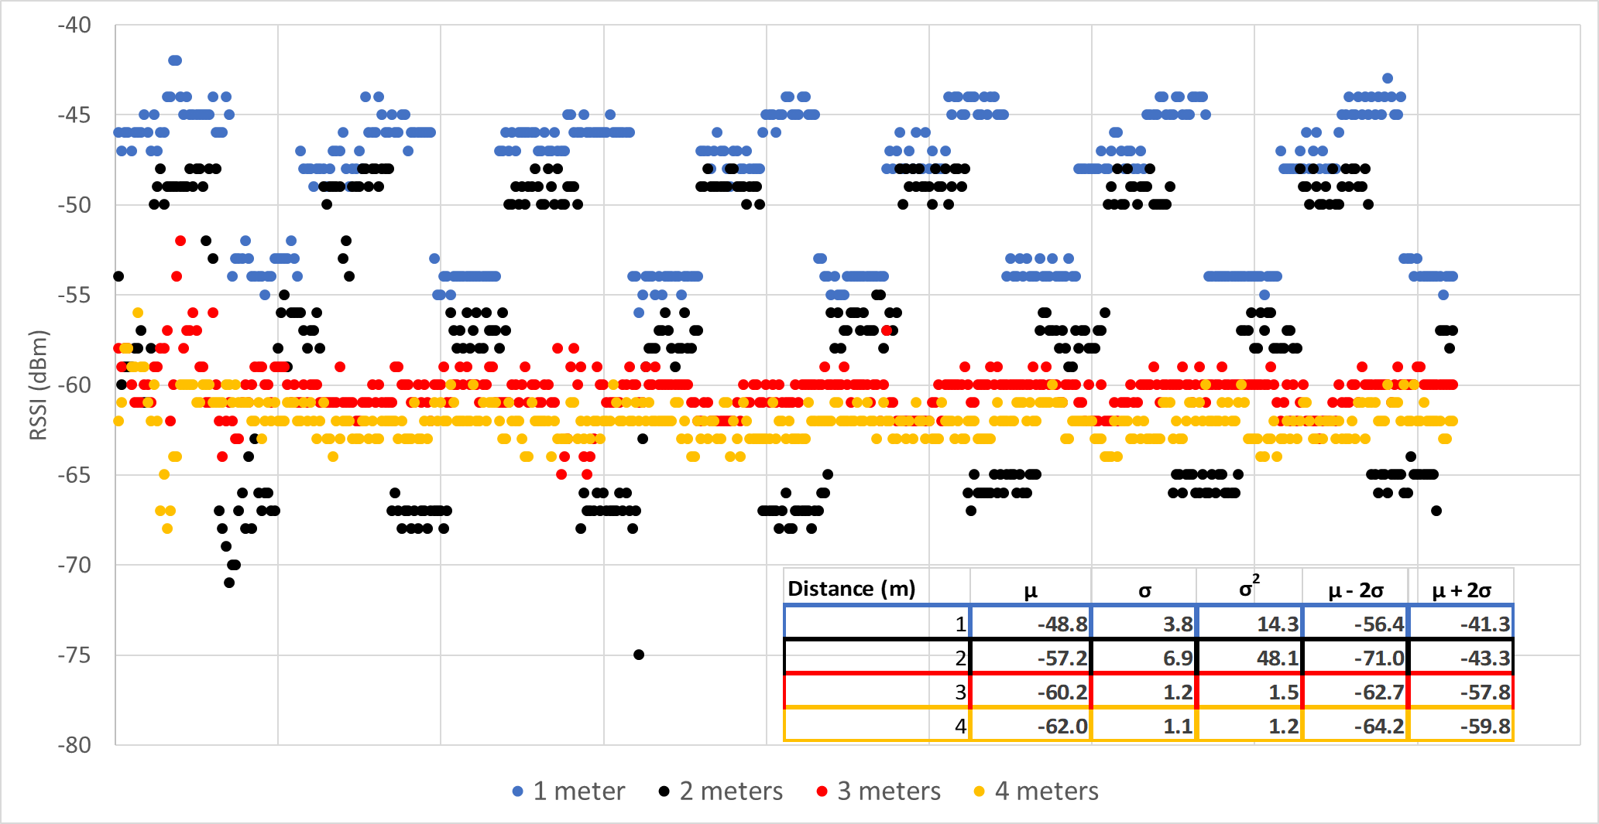
In addition to informal testing done each every day when tweaks are made to the code, we have developed an Android app with inputs for test duration, sample rate, and buffer size (used to average very noisy RSSI reading) to analyze the system’s performance under various circumstances. All test run so far have been conducted to test the Android Application “Data Management and Algorithms” block. In playing with the buffer size input, we found that a buffer size of roughly 20 points generated a fairly clean output corresponding to distance if continuously accepting data points (sample rate = fastest = 1 sample per RSSI reading). However, if we decimated every other RSSI reading (sample rate = 2) and reduced the buffer size to 10, we would still update the Android application at the same frequency as with buffer size = 20, sample rate = 1, but the data was too noisy which is why we stuck with buffer size = 20 for MDR. After arriving at our ideal buffer size and sample rate, we ran the Android app at distances of 1m, 2m, 3m, and 4m in the MDR conference room and collected 1000 RSSI data points for each. We used this data to calculate standard deviations, variances and 95% confidence intervals at each distance. Using these values, we accurately set 3 ranges of RSSI values corresponding to relative distance of the tracking tag from the phone. However, these ranges were hard-coded for the MDR room environment. The results of this experiment can be seen in figure 5 below.
Figure 5: Testing
We still need to conduct tests to estimate the effects that different environments can have on RSSI readings. We plan to place our tracking tag in areas a wallet or keys may commonly find themselves such as a pocket or a backpack. We plan to estimate average attenuation and standard deviation in these scenarios and then implement them in our code, so our system can work in these more complex environments.
To test our power specification, we will run our system continuously for one day using a new battery. We will find out how much voltage is left on the coin cell after that day. By comparing this voltage to the 3dB voltage of 2.12V, we can estimate how long it will take to reach the 3dB voltage if our system was continuously running as it would be when in use.
We will test the specification for leaving the vicinity of your phone (or leaving vicinity of tag with phone in hand) by moving away at a walking pace. If our system can recognize that you are moving away with no obstructions, we can prove the simplest case works. However, to prove our system is robust, we will also conduct the same test when the phone is in your pocket to make sure the system works even with that high-level of interference.
All other specifications will be simple to test. Pressing an icon on our app will ring the piezo buzzer on the tag. A push button on the tag will ring the phone. The area and thickness specifications will be measured with calipers.

Team Organization
Our RADIUS team is composed of two Computer Engineering students: Ibrahim Tahoun and Titus Rwantare, and two Electrical Engineering students: Richard Brown and Cormac Kennedy. The project consists of two pairs, each composed of an electrical and computer student to handle different aspects of team responsibilities. On the Android Application end, Cormac and Titus are responsible for handling incoming signals to the phone and evaluating trends in signals. On the Thunder Sense development board end, Richard and Ibrahim are working to configure the board layout to connect with I/O components, power consumption, as well as transmitting signals to the phone. Our team is handling the project considerably well given our limited schedule overlap. During our meetings, we set short-term responsibilities for each team to cover over the next week. Our Gantt chart has a layout of our long-term objectives, but due to our team effort being focused on the application for MDR, all team members have taken initiative to learn and develop the Android application side of the project.
At the beginning of the project, our team struggled to communicate on a unified platform, until Cormac and Titus took initiative of setting up Slack for the team to use and linking it with a GitHub project. This enabled us to keep track of our responsibilities, share progress, and update our code all on one platform, increasing transparency between team members.
Cormac has helped the team by taking extra time to edit and organize the application code to be uniform so that our progress could remain consistent. Given that team members practice different coding habits, it was key to keep clarity among the team when working on the project at different times. Detailing the code to clearly to keep track of revision history was encouraged to cement habits that are used in the professional field.
At the start of the project, Titus helped guide the initial steps of the project by researching the requirements and benefits of Bluetooth over other mediums of communication, unifying team efforts in our approach to the project.
Richard is the leader for PCB design for the project. Although our efforts were not focused on hardware this semester, he took initiative to create a full library in Altium of the components that will be laid out in our final product, having foresight of what will likely be one of the hardest parts of this project. Ibrahim and Richard began working on the software to test the research that was collected at the start of the semester. Combining their shared electrical and programming knowledge to start the processing algorithm helped kickstart the application successfully.
Ibrahim is the team manager and has taken the responsibility of keeping track of the team’s progress throughout the semester. He created schedules for the team to follow when team members are working separately, organized weekly meetings with the advisor, and set up PDR and MDR evaluations.
Shared initiative and care for the project has allowed the team to progress persistently on the project, with negligible struggle in the form of teamwork. As the team faced difficulty on one half of the project in the first semester, they adjusted their responsibilities to overcome challenges produced in the Android application to produce a demo-worthy prototype.

Beyond the Classroom
Cormac Kennedy – Until this semester, I had no experience in wireless communication. Although engineering a Bluetooth product was new to me, my experience coding hardware in C allowed me to quickly read and understand the tracking board source code. In viewing this source code, I learned a decent amount about the GATT profiles used to enable Bluetooth communication. While running experiments to characterize RSSI values at different ranges, I learned precisely how much noise to expect in Bluetooth signals at these ranges. This knowledge along with noise-related knowledge gained while reading on Bluetooth alternatives have provided me with a good idea of advantages and disadvantages of various wireless mediums. When I graduate, I am going to work on PCBs installed inside planes and rockets where wireless communication is widely used.
Titus Rwantare – The most significant area I’ve developed in during this semester has been understanding the workings of the Bluetooth protocol. I found the Bluetooth SIG documentation to be very detailed, but clear to read. I needed to learn how to develop in a new software suite for the Bluetooth Development Kit which introduced me to wireless radio terminology, but also wider used development protocols like SPI and I²C. I also feel I’m more competent at using Version Control tools like GitHub and team communication platforms like Slack. These collaboration tools will forever be useful to my future endeavors as a professional.
Richard Brown – During the Fall semester I was able to refresh my Java skills and learn my way around the Android studio IDE. From this experience, I also learned about the software development life cycle, and how to develop software in teams by using tools such as GitHub for version control. The skills listed above even helped me successfully complete an interview for a Java Developer role with ISO New England in which I was extended an offer of full-time employment. Some useful resources that have helped me along the way are YouTube, Stack Overflow, Silicon Labs reference guides, and my own group members.
Ibrahim Tahoun – My largest area of growth this semester has been understanding Bluetooth protocols. Learning the workings of attribute profiles to create Bluetooth entities and how to configure the development board to implement said attribute profile. Another thing I learned about was the Simplicity Studio SDK and Android Studio interface for programming both the application and the development board. Learning how to operate on new programming platforms and developing code as a team using tools like GitHub are skills I am excited to carry into my career after graduation.

