Preparation of Senior Design Project Report
First A. Author, EE, Second B. Author, CSE, Third C. Author, EE, and Fourth D. Author, CSE
Abstract—This is an editable template. You should follow the format of this template in writing your SDP MDR report. Your abstract goes here should be one paragraph.

INTRODUCTION
S
tart with the statement of the problem. What is the problem that you are trying to solve? How big is this problem? Include citations that demonstrate that your problem is significant.
Put your problem in to context. How have people solved your problem in the past? Has the problem changed with time? What are the impacts on societal impacts of your problem? How does your problem effect individuals?
Summarize the requirements analysis that you performed. How big can your solution be? How much power can it use? How will someone use your solution? List the specifications in a Table as shown in Table 1.
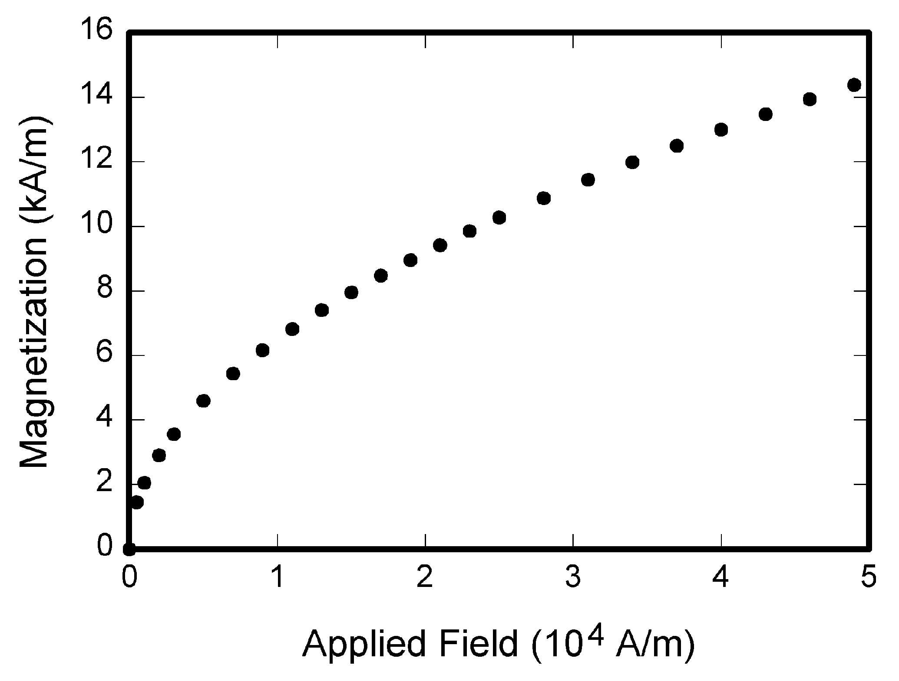
Fig. 1. Magnetization as a function of applied field. Note that “Fig.” is abbreviated. There is a period after the figure number, followed by two spaces. It is good practice to explain the significance of the figure in the caption.

Design

Overview
How will you solve this problem? What technology will you use? Why do you expect that this technology will solve your problem? What other technologies did you consider? Why did you not choose these alternatives.
Include a block diagram as a figure. Describe each block in the diagram. What specifications will each block meet? How do these specifications collectively guarantee that the system will meet the overall specifications?

Block 1
TABLE I
Specifications
Specification | Value
Weight | <10kg
Height | <10cm
Length | <5cm
Width | <10cm
Battery Life | >5 hours

Describe what this technical block will do. Explain what technology you will use to build this block. Detail which techniques from courses you will use to build this block. List what you need to learn in able to build this block. Explain an experiment you will perform to design or test this block. Explain how you will analyze the results of this test.

Block 2
Describe what this technical block will do. Explain what technology you will use to build this block. Detail which techniques from courses you will use to build this block. List what you need to learn in able to build this block. Explain an experiment you will perform to design or test this block. Explain how you will analyze the results of this test.

Block 3
Describe what this technical block will do. Explain what technology you will use to build this block. Detail which techniques from courses you will use to build this block. List what you need to learn in able to build this block. Explain an experiment you will perform to design or test this block. Explain how you will analyze the results of this test.

Block 4
Describe what this technical block will do. Explain what technology you will use to build this block. Detail which techniques from courses you will use to build this block. List what you need to learn in able to build this block. Explain an experiment you will perform to design or test this block. Explain how you will analyze the results of this test.

Project Management
Start with a table listing the status of your MDR goals. What have you accomplished? What is left to be done? Describe the progress in more detail in the text of your report.
Describe how the team is working. What are the expertise of each team member? How have you been helping each other out? How is your team communicating with each other?
Include a Gantt chart to demonstrate the work so far and the plan for the future.

Conclusion
Summarize the current state of the project. How did you get there? Where are you going?
Describe your plans for the future? What difficulties do you expect? How will you get there?

Appendix
Appendixes, if needed, appear before the acknowledgment.

Acknowledgment
You may not have any acknowledgements, but this is the place you thank anyone that donated equipment or gave you advice on your project.

References
- G. O. Young, “Synthetic structure of industrial plastics (Book style with paper title and editor),” in Plastics, 2nd ed. vol. 3, J. Peters, Ed. New York: McGraw-Hill, 1964, pp. 15–64.
- W.-K. Chen, Linear Networks and Systems (Book style). Belmont, CA: Wadsworth, 1993, pp. 123–135.
- H. Poor, An Introduction to Signal Detection and Estimation. New York: Springer-Verlag, 1985, ch. 4.
- B. Smith, “An approach to graphs of linear forms (Unpublished work style),” unpublished.
- E. H. Miller, “A note on reflector arrays (Periodical style—Accepted for publication),” IEEE Trans. Antennas Propagat., to be published.
- J. Wang, “Fundamentals of erbium-doped fiber amplifiers arrays (Periodical style—Submitted for publication),” IEEE J. Quantum Electron., submitted for publication.
- C. J. Kaufman, Rocky Mountain Research Lab., Boulder, CO, private communication, May 1995.
- Y. Yorozu, M. Hirano, K. Oka, and Y. Tagawa, “Electron spectroscopy studies on magneto-optical media and plastic substrate interfaces (Translation Journals style),” IEEE Transl. J. Magn.Jpn., vol. 2, Aug. 1987, pp. 740–741 [Dig. 9th Annu. Conf. Magnetics Japan, 1982, p. 301].

F. A. Author from Lexington, Ma (e-mail: author@ boulder.nist.gov). S. B. Author, Jr., from Auburn, Ma (e-mail: author@lamar.colostate.edu). T. C. Author from Quincy, Ma (e-mail: author@nrim.go.jp).

