Abstract — A continued area of weakness for digitalized chess is its failure to replicate the experience of a physical set. Our solution is a chessboard that bridges the gap between the physical and virtual world. Remote Chess allows users to play across the Internet using two physical chess boards. It utilizes RFID technology to detect the type and movement of pieces which is then communicated to the opponent’s board through LED indicators.

INTRODUCTION
The game of chess has been enjoyed for over 1000 years with just chess pieces on a simple chessboard [1]. However, as technology advances, so too do our forms of entertainment. Everything around us is becoming more digitized. Digitalization has made many things more connected and accessible than ever before but there is a cost. It has made many of our experiences less intimate, forcing most of our daily interactions to be behind computer monitors, touchpads and mouse clicks. The game of chess is no exception. Today, the Internet chess server, Chess.com boasts over 20 million members [2].
We have seen a few designs concerned with this problem such as SquareOff and Chesstronic Smart Chess [3]. SquareOff is an internet-connected automated chess board which uses pressure sensors to detect a move and a magnet-based system to make your opponent’s pieces move on your board. The problem we see with this design is that it has no capability to uniquely identify a piece, so it assumes the piece above the square is correctly placed. The utilization of pressure sensors makes the game feel unnatural as you have to press down on the piece before and after each move. Their implementation of magnets to move pieces has made their chess pieces un-aesthetically small relative to the chess square in order to reduce the collision/weight of pieces. Chesstronic is an internet-connected LED based board with magnetic relay switches as its sensing system. Chesstronic also does not uniquely identify chess pieces and displays the opponent’s move on the board with LEDs which are in the corner of each chess square. Both projects have a combined total of over $200,000 raised on KickStarter [3] which shows that there is a demand for such products.
Our goal with Remote Chess is to provide the best of both the physical and virtual reality, where we overlay a physical board game into a virtual space, providing an interconnected and holistic experience. Our solution is an Internet-connected LED based chess board which utilizes RFID technology and LED diffusers.

System Specifications:
Requirement | Specification
Sleek and Portable Design | Board Height <=5cm
Tournament Sized Chessboard. Standards set by FIDE | Square Length 5cm-6cm
Piece detection from anywhere within a square | Detect Piece <= 1 mm away from edge of square
To ensure fluid gameplay, have a “fast” response time | Response time <2s
Clarity and Aesthetically Appealing Chessboard | LED Indicator Diffusion is “>80%”

Design

Overview
What makes RFIDs unique is that it allows our board to distinguish individual chess pieces while providing a sensing system that does not interfere with the integrity of the classical game as opposed to pressure, photosensors and relay switches. The idea of “self-moving” pieces was out of the scope for this project, so we opted to use LED indicators to show the opponent’s move on the board. However, instead of Chesstronic’s implementation of LEDs at each corner of the chess square, we will be lighting each the chess squares with a LED-diffusion setup. Below is a detailed diagram of the communication protocols between the PCB, Android Application and the Server.

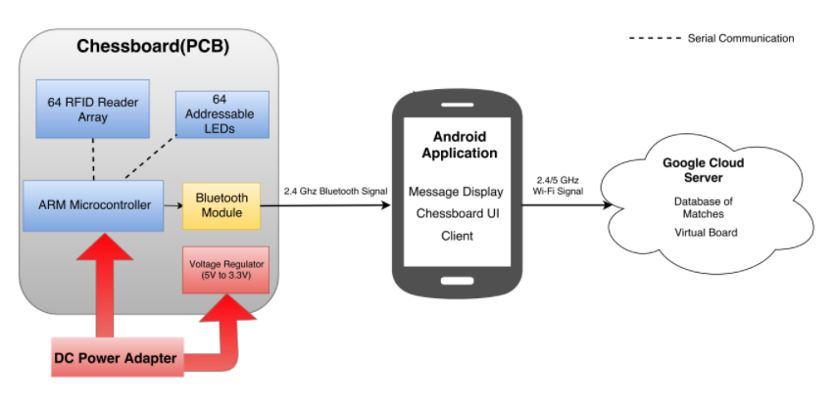
Fig 1. Block Diagram

RFID Sensing
The chessboard is able to fully sense both players moves using RFID readers and tags. As shown in Figure 2. each chess square has its own associated RFID reader, where the center of the chess square is aligned with the center of the RFID reader antenna and attached to the base of each chess piece, there is an RFID tag for unique identification. Our main concerns with utilizing RFIDs was how to deal with RF interference, choosing RFID reader/tags with the right read range and pricing.
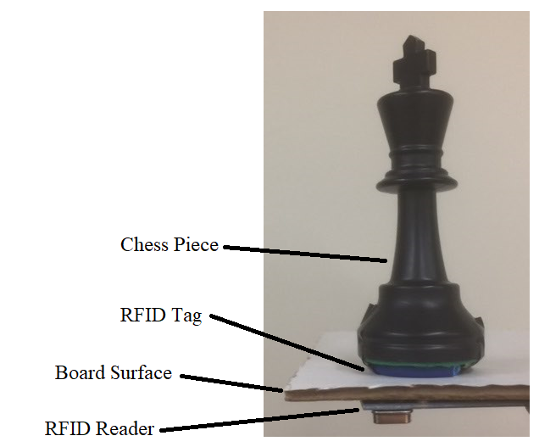
Fig 2.Example of RFID Identifying Chess Piece

Our specifications for choosing an RFID reader and tag was that the reader be able to detect a chess piece <= 1 mm away from edge of square and that the tag be small enough to fit into the base of our smallest chess piece -the pawn. We chose our chess square size and the associated chess pieces based on the square size actually played in chess tournaments [4]. The World Chess Federation recommends chess squares have a length of 1.97”-2.36” to be considered tournament size [4]. Our board has chess squares with lengths that measure 2.25” and our smallest chess piece, the pawn, has a diameter of 1.06” (roughly ¼ of a chess square length). Based on our chess square size and our range specification, the reader has to be able to detect a tagged pawn anywhere within 26.5mm of the center of the chess square as shown in Figure 3.
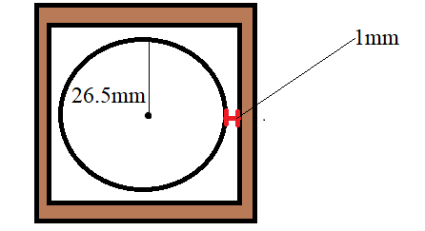
Fig 3. Diagram of the measurement method/system

Figure 4 shows the reader/tag chosen for the project, the MFRC522, a high frequency RFID reader, which came with its own tag($diameter≈1"),$ as its manufacturer specifications aligned with our read/range and its tag can fit under the pawn. Also the reader/tag pair could be purchased directly from a chinese based manufacturer for $1.78.

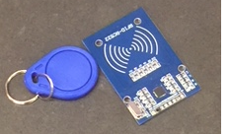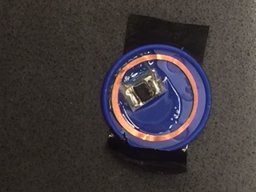
Fig 4.RFID Keychain Tag(left) with Reader(Right) Fig 5.Inside of Keychain

At the initial stage of the determining the reader/tags needed, we ordered two(so we could also test for presence of interference) MFRC522 reader/tags from a domestic seller on amazon for around $14.00 (the fastest shipping method from Chinese supplier would take almost 2 months).
Before we began testing the RFID reader/tag for its range and interference we used online resources to familiarize ourselves with wiring the reader for SPI, as shown in Figure 6., and using various open source arduino uno libraries for the MFRC522 [6,7].
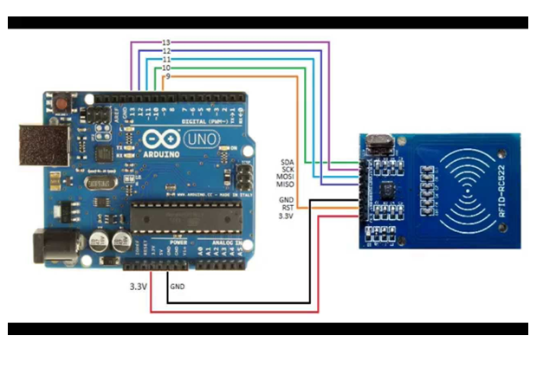
Fig 6. Arduino SPI Connections to a RFID Reader [9]

Once we were able to set up the reader with the arduino we set out to test its read range and interference by simulating a chess square with a reader underneath it and a tag placed on its surface as shown in Figure 7.
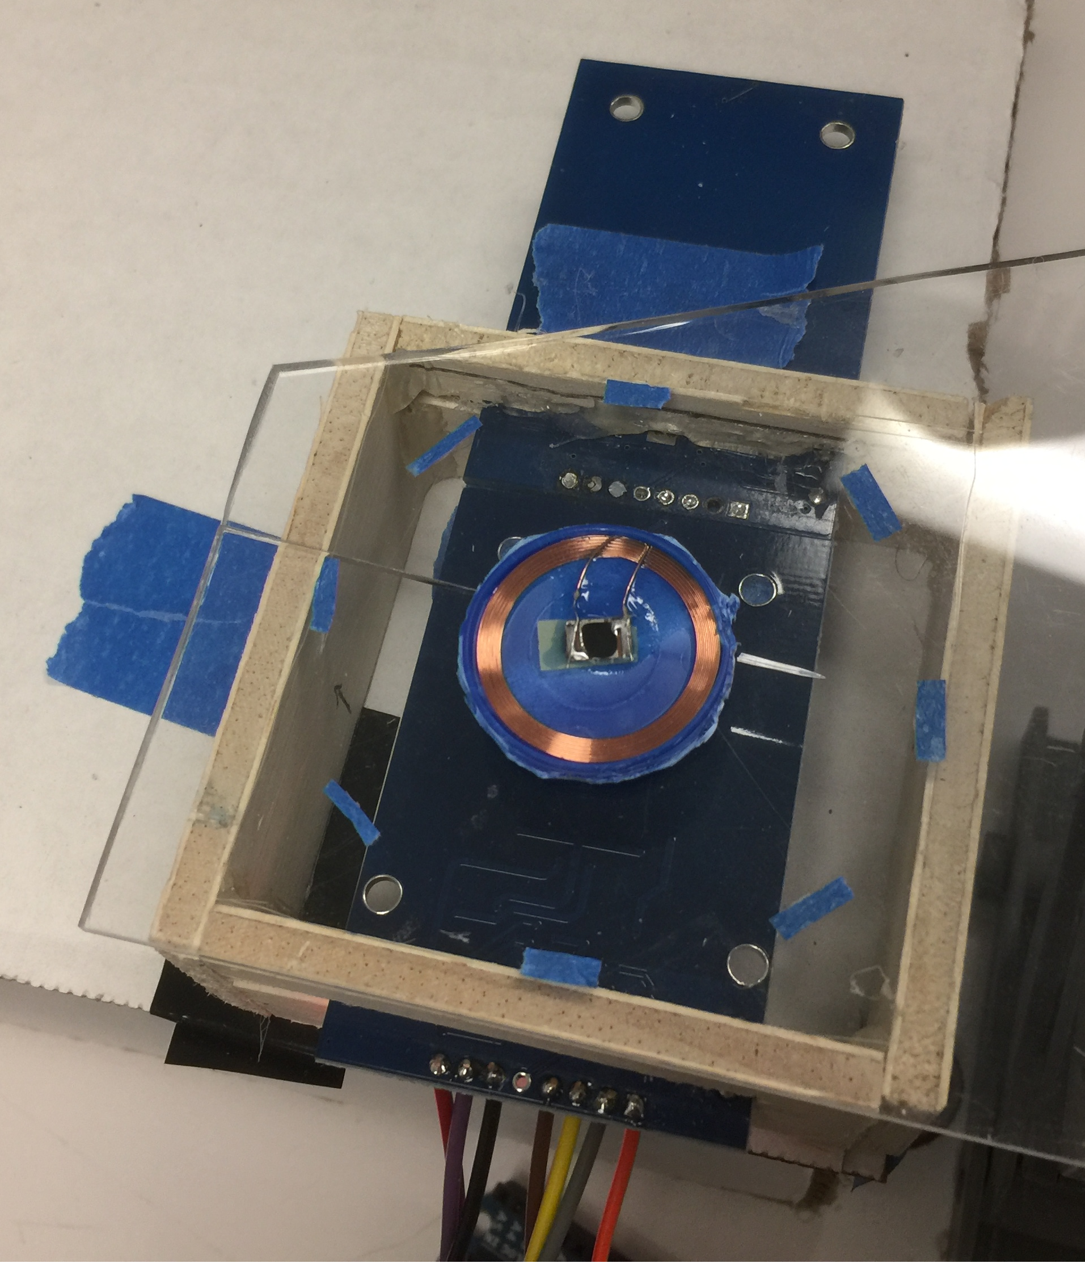
Fig 7. Range Test Set-Up

The surface used 2mm thick plexiglass where the distance from the reader surface and the top of the plexiglass is 8mm (enough to fit in the LEDs which are used as move indicators).
We tested the read range by moving the tag to various locations within the chess square, making sure the reader was able to detect the tag within our specifications. Our initial range test results showed did not meet the range specifications but we were able to resolve the issue by increasing the readers gain setting through the library. To test for the presence of interference, we connected two readers side-by-side and observed how that affected the read range. We observed that in the worst-case scenario, the tag can only be read when >3mm from the square’s edge adjacent to the 2nd reader. When multiple readers are within each other’s interrogation(read) range, their range is decreased [8]. For MDR, our solution (what we did for MDR) was to route the RFID readers under the black squares to one control line and the RFID readers under the white squares to another. When reading a white square, the readers in the adjacent black squares can be turned off and vice versa. This solution allows us to minimize the number of parallel control lines and the amount of RF interference. However, this solution yields a read time between each square of about 10 ms which means that it will take about 640 ms to cycle through all of the squares on the chessboard. This read delay had potential to cause our response time specification (<2s), defined as the time from when player moves a chess piece to a new square and when the LED on the opponent’s board lights up, to not be met on a fully 8x8 Board. For CDR, we resolved the delay issue from our first implementation by only turning on the reader’s antenna when needing to read from it’s square else it’s off. The delay for turning the antenna on/off is <1ms. We then ordered 140 MFRC522 readers/tags from a chinese supplier.
One of the challenges we faced in dealing with a large number of devices the quality of the readers, and their varying device properties.Figure 8 shows the variability of 4 readers, tested at various gain settings, and how they compared to the range specifications. About ⅙ readers were not used as they did not meet the range specification.

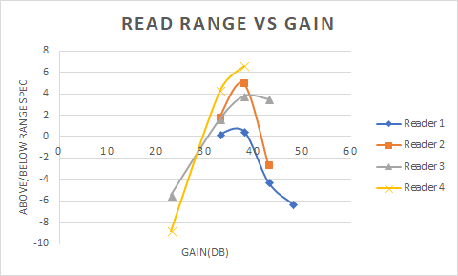
Fig 8.Range test on four readers at gain settings of 18,23,33,38,43 and 48dB.

At lower gain settings, some readers was not able to detect the tag whatsoever. At higher gains, some readers could not read tags at all. We believe this is due to some readers producing interrogation signals that are too strong which drowns out the reflected signals coming from the tag.

LED indicators
To reflect the opponent’s move on the board we decided to light up the square with opponents piece and the square to where the opponent moved the piece. Each chess square would be associated with two addressable LEDs, that diffuses its light through a piece of plexiglass lined with velum on one side. The LEDs will be on a single serial protocol to which minimizes the number of connections and provides a more aesthetic look than existing products. Developing the lighting system was closely aligned to configuring RFID readers since the readers’ ability to read the square decreases the further away from the chess top it is. We ended choosing a spacing of 8 mm in our final design. Implementing the lighting system consisted of cutting a LED strip to individual LEDs and re-soldering them with extension wire. As shown in Figure 9, each chess square contains 2 LEDs installed on the sidewall, total of 128 LED pieces used to implement the design.

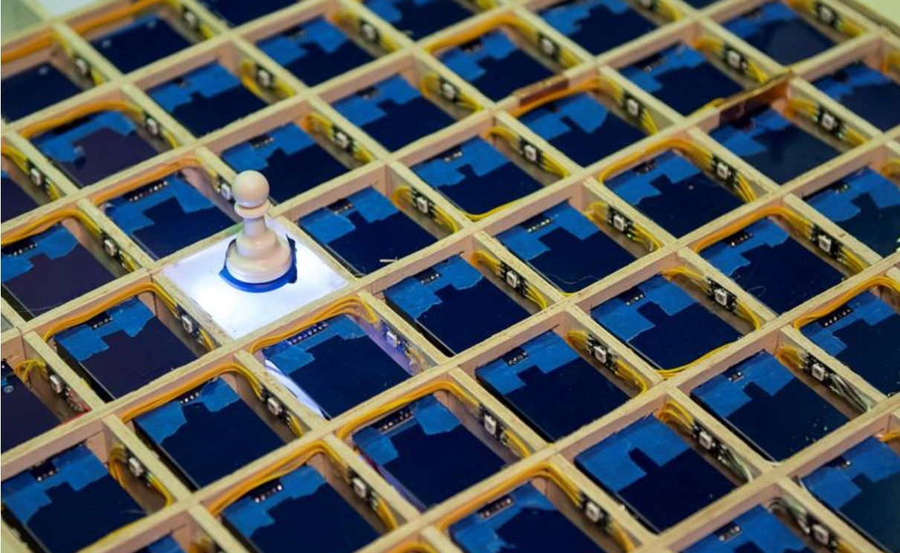
Figure 9. Demo of LED indicator on one chess square[10]

As for the chess top material, light diffusing square tops, it was a challenge to find an adequate material. Tests with 3 different acrylic and plastic materials has been done, and 2 mm thick plexiglass with attached vellum underneath was chosen for the final design on the claims of providing a thin and sturdy surface while resulting an uniform light dispersion.

Android Application
The android application, programmed in Java, served as an intermediary between the board and the server. The application displayed a notification system when a move has been made, a missing piece notification to alert the user when a piece has been removed from the board and a record of the preceding moves. For MDR, the android could communicate with a Bluetooth module and was able to display the correct square and piece ID. For CDR we required a button to send a move to the server and display the move on the board, but this was removed from our final design to allow for more fluid phone-free gameplay.

Server
We used a server/client model where we hosted a server through the Google Cloud that will connect to the android applications allowing for successful communication between the two boards. It will also allow the user to find a new chess match and it also keeps a record of the moves made. For MDR the server can only record the moves made on the board but by CDR the server has full functionality. For our final design the server is able to create a communication line between 2 chessboards or between one chessboard and an UI that is either controlled by a free source chess engine, such as Stockfish, or by another human opponent. This server can be connected to any chess engine that uses the UCI protocol. The UCI protocol is the protocol used to communicate with chess engines.

Project Completion
The following is a chart of how our final design met with the specifications of the project. Measuring the light intensity of each square was not necessary due to the adequate light intensity of a very bright NeoPixel addressable LEDs. The user is able to detect the move indication in almost any kind of environment. Moveover the high device density in our project resulted us to push the chessboard size to its maximum allowed sizes: 5 cm height to create more rooms for the wire connections underneath the board, and 6 cm for the square length to avoid overlapping of RFID readers.
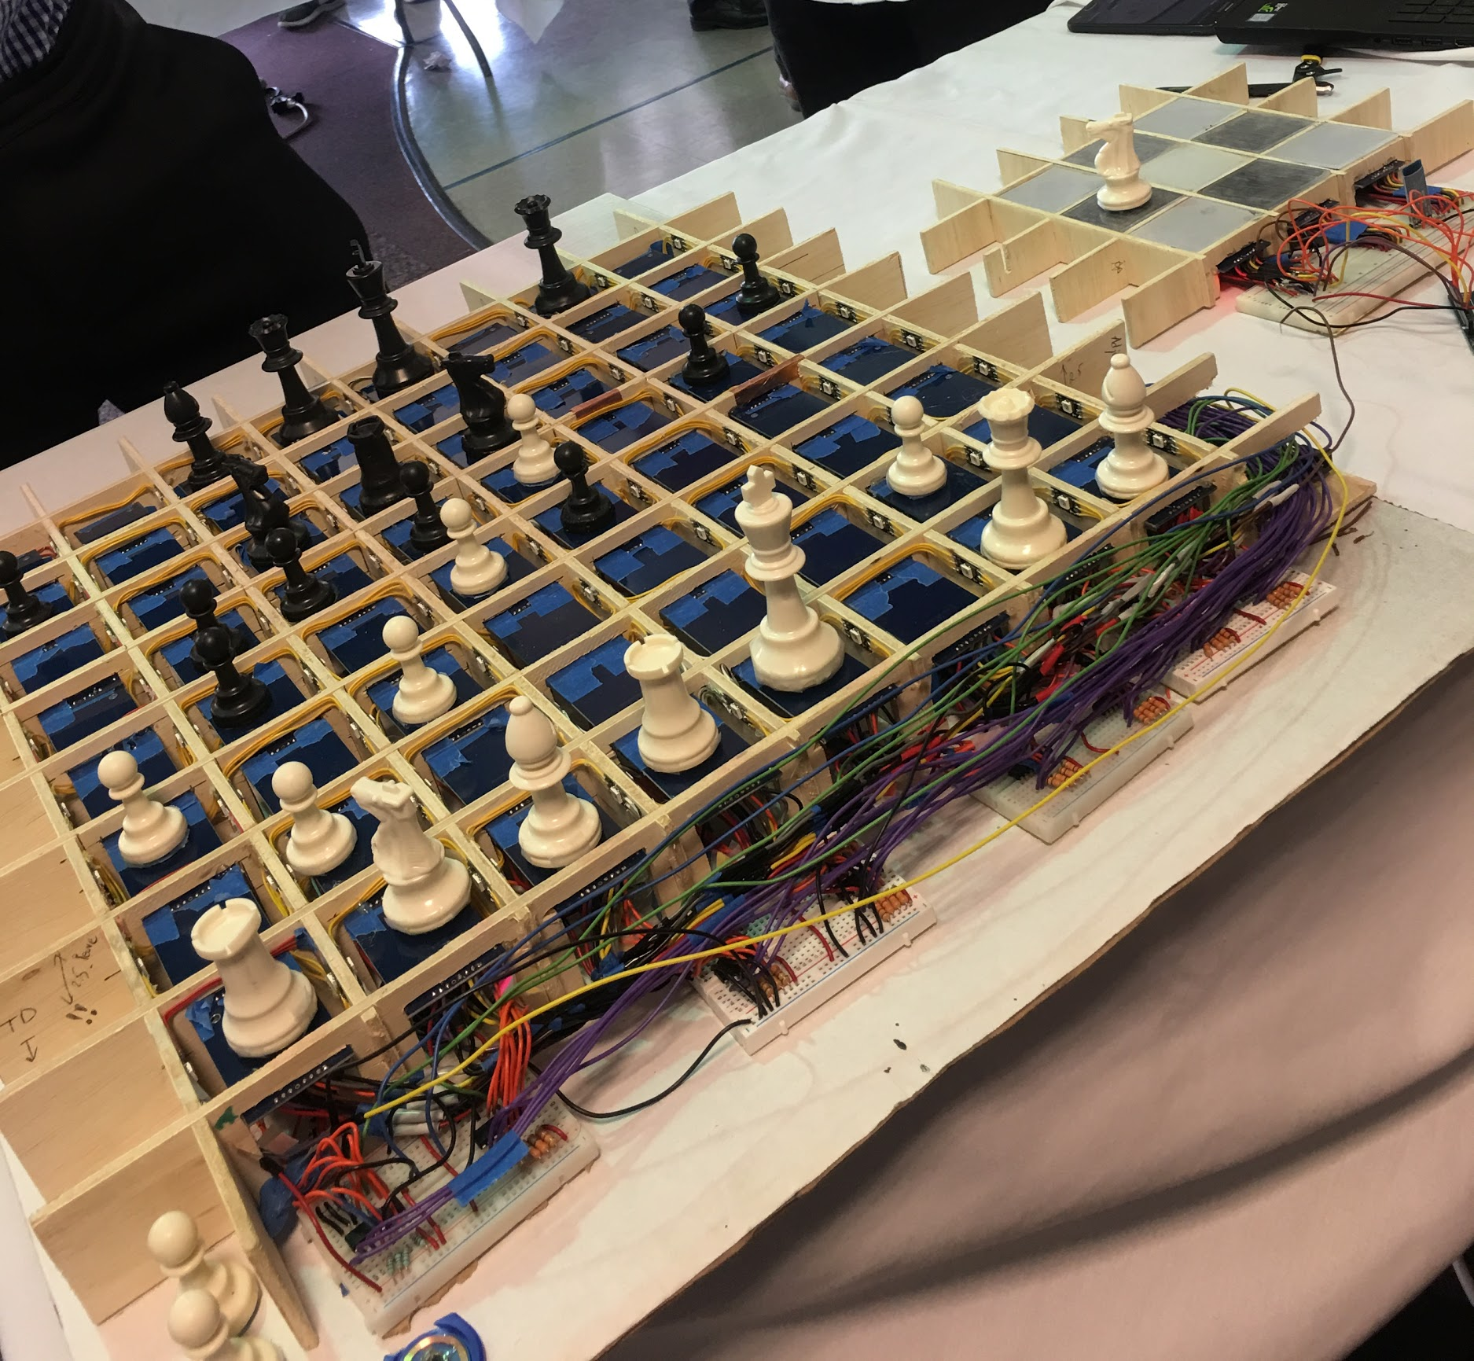
Fig 10.The 8x8 board is shown without the acrylic square tops

Specification | Design
Board Height <=5cm | Board Height: 5cm
Square Length 5cm-6cm | Square Length: 6cm
Detect Piece upto 1 mm away from edge of square | Each reader test and met the requirement
Response time <2s | Response time (< 2s)
LED Diffusion is “>80%” | LED is visible in room lighting
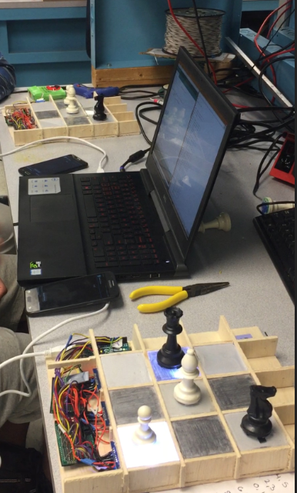
Fig. 11. Demo picture of two 3x3 boards having end to end functionality

Following CDR, we started the work of scaling 3x3 chessboard to 8x8, and found out that much of problem arose not from SPI issues but from the high count and density of components in the project. The project consisted of 64 RC522 readers, 128 LEDs, 8 multiplexers and a microprocessor and connecting wires with well over 1000 soldering joints. Even though this was a really time consuming process of component verification and manufacturing, we were able to finish the project before the second demo-day, with a functioning 8x8 board that had communication with a chessboard UI on our server..
Unfortunately, due to the limited time frame we had, we were not able to implement a power supply system and decided to use a variable voltage supply. This resulted in us frying 64 RFID readers during demo day. After this we used our two backup 3x3 boards to demonstrate end to end functionality to the course coordinators, Professors Hollot and Soules as shown in Figure 11.

V. Acknowledgment
We would like to thank our advisor, Professor McLaughlin, for his expertise and guidance throughout our project’s development and our evaluators, Professors Soules and Taneja, for their helpful feedback at our design reviews.

Citation

[1] Horst, Remus. The Silk Road Foundation Letter. “The Origins of
Chess and The Silkroad”. http://www.silkroadfoundation.org. 12 Feb 2016. 24 Sep 2018.
[2] Chess.com. Home “About Chess.com”. https://www.chess.com.
Accessed: 14 Mar 2018.
[3] KickStarter. “Square Off - World’s Smartest Chess Board.”
https://www.kickstarter.com. 25 Mar 2017. 21 Sep 2017.
[4] The USCF's Official Rules of Chess/compiled and sanctioned by
the U.S. Chess Federation. -4th Ed., ISBN 0-8129-2217-4, David
McKay Company, INC., pgs. 165-166
[5] MFRC522: Standard Performance MIFARE and NTAG frontend.
NXP. rev. 3.9. https://www.nxp.com.27 Apr 2016.
[6] StackExchange. “Issue Sharing MISO with Multiple RC522 RFID
Readers”. https://arduino.stackexchange.com. 1 Dec 2015. 28 Oct
2017.
[7] Balboa, Miguel. GitHub. https://github.com/miguelbalboa/rfid.
Accessed: 14 Jan 2018.
[8] D. Y. Kim, H. G. Yoon, B. J. Jang and J. G. Yook, "Effects of Reader-to-Reader Interference on the UHF RFID Interrogation Range," in IEEE Transactions on Industrial Electronics, vol. 56, no. 7, pp. 2337-2346, July 2009. doi: 10.1109/TIE.2009.2012451y
[9] Rathore, Dharmendra. ElectroBuzz. “Introduction To RFID
MFRC522.” http://electrosbuzz.blogspot.com. 16 Jul 2016. 02 Nov
2018.
[10] Photo Credit to SDP Demo Day Photographer

