Blast Impact Monitoring System - MDR Report
Andrew B. Barraford, EE, Fabio Dallorto, EE, Aysha Mehjabeen, CSE, and Josh Ryan, EE.
Abstract— Research suggest that blast impacts to the whole body play a major role in the development of Traumatic Brain Injury (TBI) amongst soldiers. “While the majority of current studies focus on the direct blast-head interaction, the role of whole-body exposure to blast thus multi-organ response in blast-induced TBI remains underestimated”. TBI is a major problem facing troopers of all militaries. In the United States alone, between the periods of 2000-2014, there have been 307,283 cases of TBI. There remains a need for devices that collect data about these events for both research and early detection of TBI. In 2013 a congressional report stated, “More portable data collection instruments are needed”. The Blast Impact Response System (BIMS) is a system developed as a one-year senior design project at the University of Massachusetts, Amherst in the Department of Electrical and Computer Engineering. Our objective is to develop a wearable device to be worn by soldiers in the field and upon a blast event record important information about the blast wave as it impacts the body. This report will cover the preliminary specifications, functionality, and design of our wearable device.

INTRODUCTION
T
raumatic Brain Injury (TBI) induced by non-penetrating blast impacts is currently an active area of study because both of its impact to the individual and to society. Those who suffer TBI often experience the following disabling symptoms: Headache, Confusion, Lightheadedness, Dizziness, Blurred Vision, Ringing in the Ears, Tiredness, Mood Changes, Memory Loss, Sensitivity to Light, Nausea, Vomiting [4] and more. It is also common to see PTSD develop amongst victims of TBI [5]. The impact on society cannot be underestimated as these disabling symptoms can impact families, communities, the economic burden of TBI is estimated to be $60 Billion [6].
This problem needs more data to help develop better methods to both protect soldiers from the impacts of blasts and to improve detection of possible TBI events. There have been multiple projects to build a device that collects data on blast impacts. In our research we have found a vest developed by Georgia Tech using pressure sensors to detect and automatically collect the pressure impact [10]. This approach is very similar to our own but the project falls short from long term deployment due to the size of the device and vest. During an interview with Dr. Ibolja Cernak (See Appendix: A for biography), she explained us that there has been a few devices with the intent of collecting such data. These devices relied on accelerometers and thus the G-force that the body undergoes throughout the blast event. Dr. Cernak told us that the results were not useful for research because it is not collecting the correct data. In fact, Dr. Cernak gave us her wish list for an ideal wearable data collection system. Such device should collect the following information: peak over-pressure, magnitude and duration of the overpressure wave, the under-pressure wave and wave frequency at the skin. Ideally, this data should be collected at multiple points surrounding the torso and later analyzed by software capable to display the pressure wave as it impacted these sensors and propagates across the body—a 3D model of the impact on the body, along with charts showing wave at each sensor, would be the ideal graphical output. Figure (1) shows a blast wave and labels the important parts of the wave.
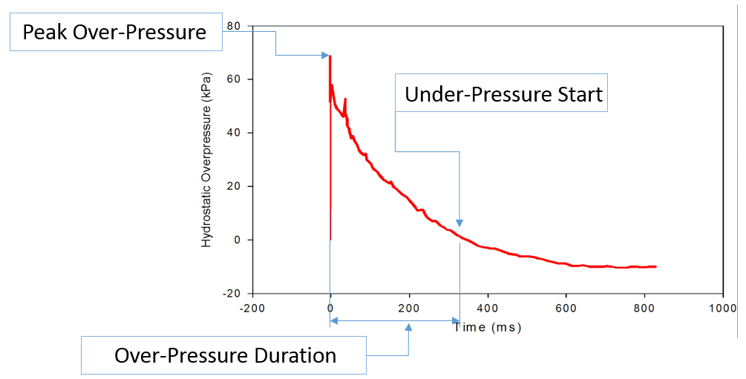
Fig. 1. Blast Wave
The design phase of our project has been the most time-consuming. As a research tool we wanted to make sure that we were focusing on the features for our device. This required us to learn the anatomy of blast waves and the physiology of blast injuries. We reached out to several experts (listed in the Acknowledgement section) to narrow down exactly what our user would want in a portable device. Our device is made up of two main components: 1, the under-vest that is to be worn over the skin and 2, a hub device that will be worn on the belt that will include the main electronics of the device. The specification goals that for our hub device based on the discussions with these experts are shown in Table I
The last challenge we had in our design phase was to find a way in which we could test our sensor and to validate their response to a blast wave. After many consultations with Dr. Michael Courtney of BTG Research (See Appendix A for biography), a research firm specialized in blast wave modeling, we designed a compressed air shock-tube to generate a model wave that we can impact on our sensors in the lab that is analogous to the waves that would be expected in a real-world blast event (See Appendix C. for design of our shock-tube).
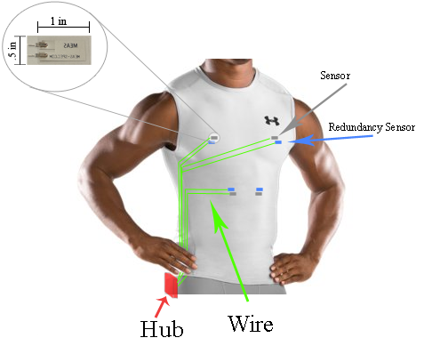
Fig. 2. Prototype Design
TABLE I
Specifications ^{[11]}
Specification | Value
Weight | <10oz
Height | <10cm
Length | <5cm
Width | <10cm
Battery Life | >72 hours
Washable True
Max kPA 500
Min kPa 70

Design

Overview
This project, having the aforementioned physical components of a wearable sensor array located as close to the skin as possible and hub for collecting and storing real-time blast data, posed some significant design challenges. Having a sensor array that is both lightweight, power efficient, and able to accurately sense blast waves is paramount to our success. We have a few options available. The most obvious sensor when considering impact sensing, the accelerometer, measures g forces seen by the sensor as it is accelerated in a specific direction—as previously mentioned, this kind of data point is marginal in this field of physiological research. Also available are pressure transducers these give an accurate pressure reading at certain pressure ranges. Unfortunately, both the pressure transducer and the accelerometer require an external power supply, hence dictating a wide-spread power delivery network across the body. Pressure transducers could have worked for our application but we chose a less conventional approach. The sensor we are working with is a basic laminated piezo-electric film. The sensor measures 1”x.5”, is extremely light weight, requires no external power supply, and has a linear voltage output to pressure input response. Using a sensor that requires no power supply cuts the wiring required in the wearable by a factor of two. Also, the laminar nature of the piezoelectric material is perfect fit for our wearable, minimally invasive device.
The analog voltage output of the sensor array needs to be interpreted and stored by the hub. To do this the input signals must be converted to a time stamped digital signal and recorded in a format for later use by researchers. The hub must contain an analog to digital converter to sample the signals, a real time clock for time stamping each event, a storage medium to hold the history of blasts seen by the device, a microcontroller to coordinate and format the signal input and storage, and an adequate battery power supply. Our initial approach was to implementing our design with discrete components. This can work but through our research into components that would meet our specifications adequately it was discovered that a number of the components could be implemented as a single component, thus saving space, power, clutter, and addressing some possible data-throughput bottlenecks. The microcontroller we chose, the ATxmega 128A1 [12], contains both a real time clock and 2 analog to digital converter capable of sampling the signals at the rate we require. The chemistry of choice for the battery power supply is Lithium Polymers. We chose LiPo [13] over Li-Ion to help reduce the weight of the hub. This will be charged though micro USB port that will double as a data port. There will also be a coin battery backup for the real time clock. The storage medium will be a microSD card, chosen for its small form factor and high data transfer rates.
The output from the hub will be a csv file uploaded to a cloud based server through a direct USB link with a pc. Such csv files will be encrypted on the hub and stored securely on the server for later analysis by researchers and authorized personnel. We will also be providing a data processing program, also cloud based, that will interpret the raw data stored on the server and represent it graphically for the user.

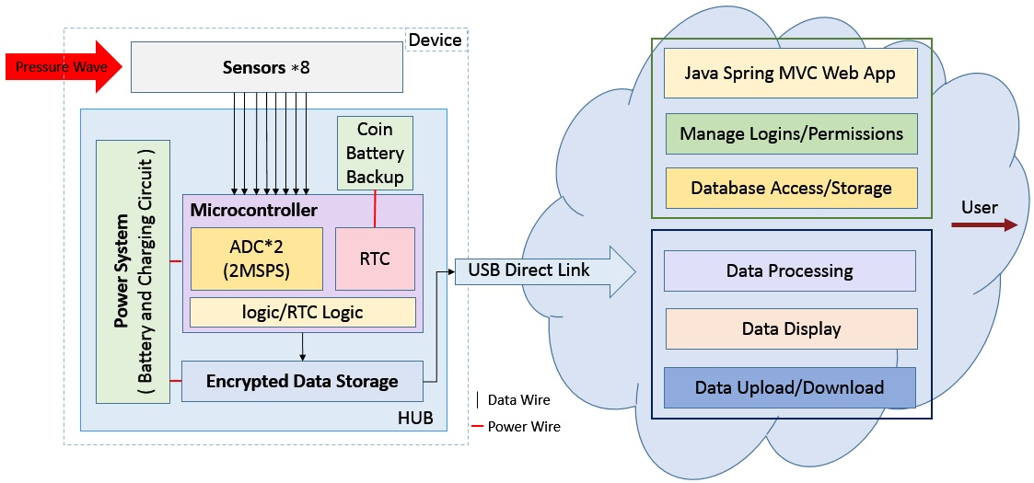
Fig. 3. Project Block Diagram

The above block diagram gives a representation of the components needed for our device. Dividing the parts up into blocks of responsibility we have; Block 1: Wearable Sensor Array and Power Supply, Block 2: Microcontroller and Encrypted Storage, Block 3: Cloud Based Storage Server, and Block 4: Cloud Based Windows Program for Data Processing. Block 1 is the responsibility of Joshua Ryan. Block 2 is the responsibility of Fabio Dallorto. Block 3 is the responsibility of Andrew Barraford. Finally Block 4 is the responsibility of Aysha Mehjabeen.

Block 1
This technical block, which is the responsibility of Joshua Ryan, will contain the wearable sensor array and the power system. For the sensor array we will be using piezoelectric film sensors. The sensors are of the of the DT series from Measurement Specialties [14]. In essence, these sensors are a small piece of laminated piezoelectric film with two electrodes attached, very light and highly flexible. The biggest obstacle to overcome in this block, and in turn the entire project, is the characterization of the voltage output to pressure wave input for these sensors. This has not been done before and therefore we have no pre-existing data to calibrate our device. The power system will consist of one rechargeable LiPo battery and one replaceable coin battery. The latter will be used as a backup for the real time clock in the microcontroller. For the rechargeable LiPo battery a small charging circuit will be need to be implemented. Having never worked with a charging circuit for such delicate battery chemistry, a bit of research as to exact implementation will be essential.
Most of the testing needed for this block will be on the piezoelectric sensors. In order to characterize the output of the sensors to an applied pressure wave from a blast we will need to simulate a blast wave in the lab. This is commonly done with a device called a shock tube, which consists of a driver section and a driven section separated by a burstable membrane. The driver section is pressurized until the membrane bursts. This creates a pressure wave front that travels down the driven section impacting whatever is placed in the opening at the end. There are 3 types of shock tubes that are commonly used in labs; compressed air, oxy-acetylene, and explosive. Both the oxy-acetylene and explosive driven shock tubes produce a more accurate pressure wave than the compressed air. For safety reasons we are not able to build either the explosive or oxy-acetylene driven shock tubes in our lab. We researched the characteristics of blast waves as well as the components of a compressed air shock tube and fashioned one out of residential plumbing PVC pipe. Such PVC pipe is rated at 450 PSI, well above the pressures we would be using.
The initial testing and characterization was indeed a crucial point of our project: at the core of every data logging device lies a reliable and effective sensor. Using the shock tube we designed and manufactured, we performed the initial testing of our piezoelectric film sensor implementation.
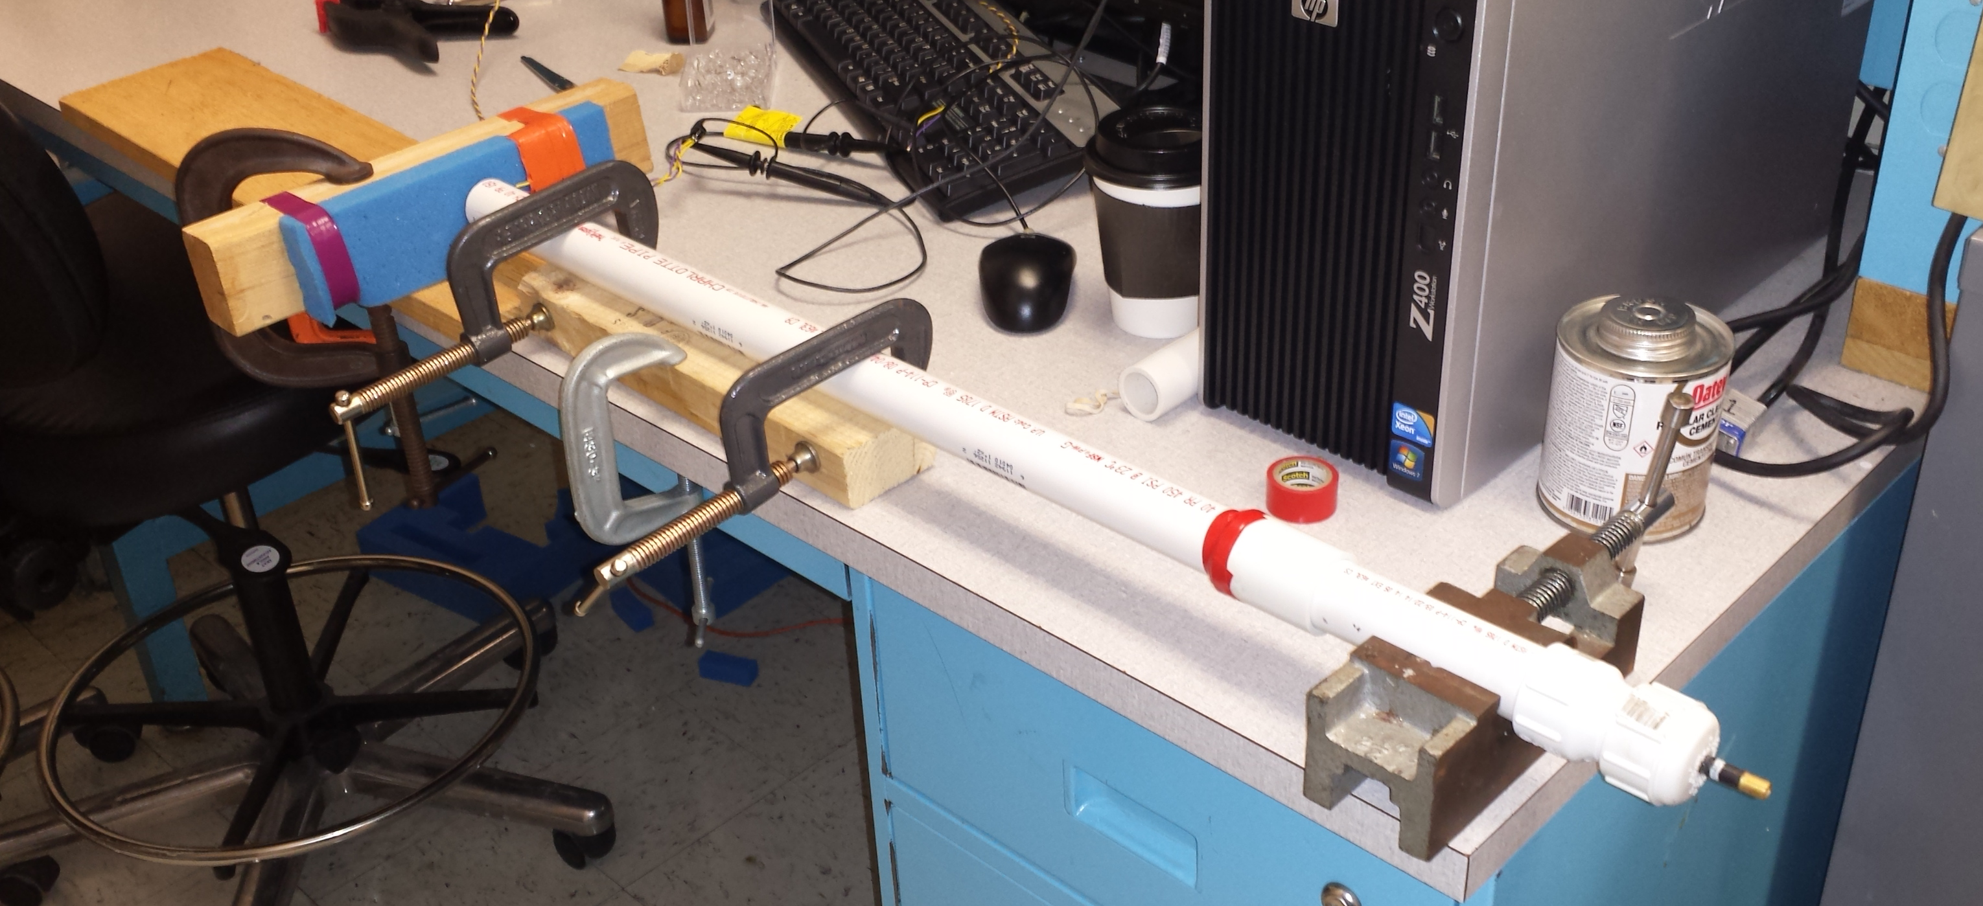
Fig. 4. Compressed Air Shock Tube
The sensor was placed directly in front of the blast-wave producing end of the shock tube, backed by a wooden board and foam padding to mimic the human tissue structure and dampening effect. We attached a 24AWG twisted pair lead to the sensor, tapped at 1 and 5 feet by the oscilloscope probes. This was done to test whether there would be any attenuation of the signal due to loss in the wiring between the sensor and the hub. Using this configuration we ran numerous tests at various pressures within the driver section. The results from these tests were three fold; 1) the piezoelectric sensor response accurately followed the form of a blast wave, 2) there was no attenuation of the signal between 1 foot of wire and 5 feet, and 3) the voltage response appeared to be linearly related to the pressure input. While these preliminary testing proved invaluable to demonstrate the feasibility of our sensing scheme, our self-made shock tube is not accurate enough to provide an accurate final calibration of our device. Ideally we would need to know the pressure at the sensor at the moment of impact rather than just the pressure in the driver section. In order to overcome this problem, we have been in touch with Rutgers University and they have offered us the use of their larger, calibrated, shock tube which will deliver a precise, repeatable shock wave to perform our final calibration, and hence helping us to better model the transfer function of the film. Knowing the upper limit of the voltage output of the sensor will enable us to determine the appropriate amount signal attenuation needed by the ADC, and in turn enabling the microcontroller to interpret the full range blasts magnitudes (~70 to 500 kPA) our device may encounter.

Block 2
This block is the responsibility of Fabio Dallorto, and its main goal is to create a robust, reliable device able to collect the pressure wave data collected by the sensor network of block one for later batch retrieval.
The main challenge to overcome when designing a data-collection tool is to gain a deep understanding of the physical phenomena to be observed. In our case, such physical event is the blast wave created by an explosion, in the form of a pressure wave travelling through air. As a starting point we had to invest a great amount of time in building up our knowledge base of this kind of events. This had deep ramifications in our preliminary design.
First and foremost, such events are short in duration (in the order of 5-15 ms), and they need to be sampled at an high rate in order to capture the fundamental characteristics of the wave, primarily peak magnitude and overpressure duration, as shown in Figure 1. The effective sampling rate to achieve meaningful results is in the 500kHz-1MHz range [9][11].
From our literature review, we discovered how the previous attempts to measurement of blast waves were mostly stationary, laboratory-based devices. However, our goal to create a lightweight, power efficient wearable device constrained by a limited budget can result problematic when trying to sample multiple channels at the aforementioned frequencies. In fact, the data throughput and raw amount of data to be stored, in conjunction with the power consumption of high-frequency ADCs, is one of our main concerns.
Our initial approach of using discrete ADCs connected to a microcontroller appeared to be troublesome, so we concentrated our research into MCUs with integrated high-speed analog to digital converters. The chosen candidate is the ATMEL ATxmega128A1. Such device has two 16 channels 12 bit ADCs able to sample at a maximum of 2 msps [12]: an interleave sampling approach gives us the possibility to sample four channels at 1 msps or eight channels at 500ksps, thus remaining in the effective sampling range for blast waves.
Even after finding a MCU capable of sampling at the required speed, the data-throughput and data storage capabilities needed could still be overwhelming—an alternative solution was needed.
In fact blast waves are accurately modeled by the Friedlander approximation shown in Figure 3 [9]:

Fig 3. Equation for a Friedlander waveform

Where P_{s} is the peak magnitude of the blast wave, and t⁺ is the threshold between overpressure and underpressure. A sample wave created with our shock tube, overlaid by its Friedlander approximation is in Figure 4.

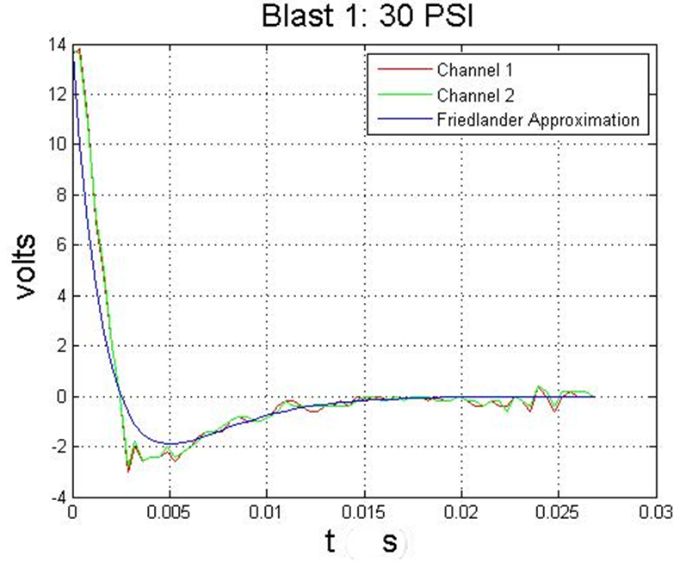
Figure 4: Blast Wave with overlaid Friedlander Approximation

Using a holistic approach to sampling and storing, we can dramatically reduce the quantity of data to be stored, while still retaining the most meaningful data points of the wave: peak magnitude and overpressure duration. While we are still exploring both techniques, and planning on implementing both approaches of direct sampling and wave approximation, the latter is a very viable option in the case we will reach unsurmountable hardware limitations when storing the sampled data. In fact, using multiple datapoints to create an over determined system, a least square approximation could lead us to the full wave form even without knowledge of either P_{s} or t⁺.
Collecting the data will revolve heavily around the ATMEL microcontroller experience we gained during Computer Systems Lab I, where we had a first introduction to microcontroller programming and data I/O. However, an additional exploration of technical documentation will be needed to implement encryption, power management, and USB connectivity.
Finally, we will need a way to prove our assumptions and the data obtained by sampling and/or extrapolation. In fact, we contacted researchers at Rutgers University and they allowed us to use their laboratory grade shock tube to test and calibrate our device. After obtaining a meaningful number of sample blast we will compare the collected data with the highly accurate data collection system at Rutgers to validate out data and its analysis.
During the preliminary research and design of this block, some courses have proven invaluable: specifically, Signals and Systems (ECE 313), Scientific Computing (MATH 551), and Introduction to Communication and Signal Processing (ECE 563) gave Fabio the background necessary to proficiently devise a possible sampling and storage scheme to overcome challenges and produce the necessary result. However, a more in-depth study of sampling theory and a deepened familiarity with MATLAB were indispensable to achieving our goals.

Block 3
This block was the responsibility of Andrew Barraford as the application architect and database access/storage block. In this block it is Andrew’s responsibility to 1. Choose a software framework. 2. Establish a working model of the chosen framework. 3. Build all layers associated with user login. 4. Build all layers associated with user-permission to access content. 5. Establish a database structure for the project. 6. Build all database access/storage layers.
One important aspect of research data is the ability to share the collected data with other researchers. This constraint was instrumental in the choice of software platform. We chose to implement a web-application so that all data would be centralized, while allowing soldiers to upload data after any event, thus increasing convenience for all parties. With that said, when talking with Dr. Michael Courtney (See Appendix: A for biography) he informed us how this data is considered to be Top Secret by the military. This raised the importance of security and privacy as a main consideration in the build of the site.
Subsystem 1: After reviewing different choices of web-application frameworks, we to use Java Spring MVC for our website. Spring MVC is an enterprise level framework that is both robust and scalable. The choice to use Java as the application framework was due to thorough use of Java in the UMASS coursework; in particular, the knowledge gained from Data Structures was instrumental in this decision. However, such academic background needed to be supplemented by additional literature about Spring MVC mainly in the form of the reference book, “Spring in Practice” [7].
Subsystem 2: Andrew had some previous experience in building web-applications derived from his professional career, so launching a Spring Application to begin this project was a matter of only a few days. The following is a list of requirements for the chosen development environment.
- Netbeans IDE 8
  - Maven Web-Application
  - Spring MVC Dependencies
  - MySQL Connector Dependencies
  - Spring-Security Dependencies
- MySQL Database
  - Schema (See Appendix B)
Subsystem 3: With security and privacy a main consideration in the design process for the software application it became apparent that a user credential management and user logins layers would be required for this project. In order to manage credentials and user sessions we deployed the Spring-Security dependencies. Spring Security offers session management and credential management as well as a wide range of resources that offer encryption functions and URL filtering. A challenging aspect was trying to determine the mechanism to handle password resets. Two choices came to mind: the first was to a list of security questions as a secondary level of authentication before allowing a user to reset their password. After considering the probability that these types of questions could be guessed, and using concepts taught in our junior year probability class, Andrew decided against this method. The second method for password reset would be to request an email link. While email is not 100% secure, it reduces the probability on our end of a breach and relies on the user to maintain the security of their own email. Therefore, this technique was chosen in conjunction with sending a random token with an expiration. Such token is stored in the website membership table, hashed and salted with the same level of security as a normal password. In order to fully implement Spring-Security, it was necessary to build the following layers:
- User Forgot Password
- User - Login
- User Registration
- Form Validations
- User Change Password

Subsystem 4: The classes associated with permissions still need to be built. Such endeavor should be completed over the course of the next few weeks. It is necessary to manage what content different users can have access too, that is, researchers shall have total access to assign devices to soldiers and view data related to those devices. Researchers should be allowed to share data with other users, and soldiers should have the ability to exclusively upload data.
Subsystem 5: Establishing a database structure was something new to Andrew. While in Data Structures and Computer Systems Lab I we were able to learn about different ways to store data, the SQL Database was not one of those. Therefore, Andrew needed to learn SQL commands [8] and implement a database structure that would be efficient, scalable and not limiting in regard to the applications features. You can see the finalized database schema in the Appendix B.
Subsystem 6: The last task in this block is building the database access/storage layers for the project. Firstly, we created a database access object (DAO [8]) as an interface then built a template to assign user data to. This allows for easy access of user details throughout the application and when using the DataSource API it also will manage the connections to the database server.
We are planning to run thorough significant user testing of the site (to make sure that it performs as intended), and to create bench tests for problem areas to make ensure correct and reliable output. This method of system testing was introduced to in Signals and Systems junior year class.

Block 4
Overview
This block, executed by Aysha Mehjabeen, handles the processing, visualization and long-term storage of data collected from impact sensors. This information is presented to the user (i.e., a researcher) on a web application through an interactive graphical interface, which allows export and import of current data.
The raw data of impact on sensors is transferred from the microcontroller hub to a computer via the USB drive and then uploaded onto the web application through the user interface. The imported file must be in the csv format, containing the following information: hub ID, sensor ID, time (in ms), Impact (in kPa). In later steps, we will only need the peak pressure, P_{s,} and the time when pressure crosses zero, t^{+,} to extrapolate the complete set of data points during the blast, using Friedlander's approximation of blast waves (Fig. 3).
The format of the file and all the data values will be validated within our application during import. In case of any inconsistencies, the user will prompted with the error message and instructed to supply correctly formatted data. Raw data from the input file is stored in a MySQL[8] database for later access and processing, as well as to record a history of all data imported by the current user.
The data points collected from the csv file (or created by extrapolation) are then plotted and displayed as graphs of pressure against time. The impact events on each sensor and each hub may be viewed layered on top of each other, or separately, depending on the user’s preferences. The user may also select a start and end time to view impacts received during that period only. We aim to provide all these functionalities on our application to allow the user to customize their own experience and adjust the available data according to the needs of their own investigation.
The data can be downloaded on the application in the form of a csv file or an image of a chart. This will allow the user to share their findings with their colleagues and store backups of the data outside of the web application.
Technical Tools
The system described in this block will be implemented on a Java-based web application on the Spring MVC framework[7]. The data parsed from the csv file is written into a MySQL database. Data display is implemented using Google Charts, which is a free, well-documented API that contains several complex, interactive and customizable options for static and dynamic charts. Google Charts[15] can be integrated with Spring using charts4j which is a Java API. Files will be uploaded and downloaded on the application by client-server communication through Spring.
Techniques
Knowledge of data structures was essential in implementing this block, to determine the best representations of the data collected from sensors. Concepts from algorithms are used to design an efficient method to search for the peak pressure and to validate new data. Understanding of Software Intensive Engineering (ECE 373) provided some familiarity with end-to-end development of a software system, especially with designing a software product around user specifications. It also helped to divide the system into modular subsystems and collaboratively develop a project using version control. Previous work experience with web development and software engineering has provided exposure to building RESTful (Representational State Transfer) [16] web applications and database management.
Research
The new information learned to implement this block includes understanding the basics of the Friedlander’s equation, the physics of blast waves, their impact on the human body and contribution to TBI. We have read recent research papers and held meetings with researchers in this field to determine the usefulness of our product and the desired functionality of the software application.
New technical knowledge obtained includes learning to work with the Spring MVC framework, controlling client-server communication and front-end development on this RESTful web API. Another new tool learned is the Google API and integrating it with web applications.
Experiments
The various features of this block will be tested by first logging all interesting events and writing scripts for automated testing. Some manual methods to test the user interface will include reproducing possible user actions on the web interface to detect possible faults along the execution path. The data validation can be checked by supplying inconsistent types of files and invalid data values. The extrapolation feature can be checked by plotting the Friedlander equation and comparing to the actual graph and data points obtained on the sensor.

Project Management
After receiving feedback from our evaluators during PDR and lengthy discussion with Dr. Cernak and Dr. Courtney, we reshaped our MDR goals. In fact, we devoted a large amount of time to researching the physical nature of blast wave and the physiological repercussion on humans. This research and academic collaboration was an invaluable tool in reassessing our design needs and goal, but slowed us in the creation of hardware prototypes of our project. Our plan for the winter break is to focus our effort to accomplish the newly redefined goals of our project in order to be up to speed for CDR.
Our team is very diverse and reflects the multiple interest areas of our members: Andrew is very well-versed in web development, while still being resourceful on the hardware side. Joshua is an excellent troubleshooter, with a passion for electronics and a very hand-on approach. Fabio likes to see the big picture and his knowledge in Communication and Signal processing is a fundamental asset given the scope of the project. Lastly Aysha, the only CSE in our team, is a reliable person able to create elegant software solutions to achieve our final goal.
As far as logistical arrangements, we are holding weekly meeting with our advisor, Prof. Vouvakis, separate team meetings in the lab to discuss our progress and brainstorm new ideas. In fact, while having fixed responsible persons for each block, we like to exchange opinions, ideas, and critiques across different block. We find that a structured, yet open, team organization is the most conducing to effective and meaningful work.

Conclusion
At this time, we have completed a high-level design of our overall system and interaction between subsystems. We have done this after thorough research and active discussions with researchers, advisors and technical experts in the field. An essential step in this process was determining our target user and collecting information on the final user’s needs.
We built a shock tube as a tool to calibrate the pressure from a blast to the voltage response on a piezoelectric sensor. We have decided on the ideal dimensions of our sensor network and contacted our supplier. We have determined useful parts to purchase in the near future that will be feasible with respect to our budget and will significantly propel our project forward. We plan to complete our implementation of a network of 8 piezoelectric sensors, integrate it with a wearable vest and connect it with the main logic unit that will sample and store relevant responses. This storage hub will then be able to transfer collected data via a USB drive.
We have built a web application that stores and validates user credentials, allowing for user sign up and log in. Our aim is to also implement access privileges for individual users or groups. We currently have a second application that allows data to be imported through file upload options, displays data graphically and can send data back to the user via file download. As our next steps, we will integrate these two applications to create one where a user must log in to be able to import data on to their account, visualize and interact with selected data sets, and share it with other users.
We plan to make our system more robust and reliable, by accounting for independent and total system failure. We would also like to implement encryption on our storage hub, so as to further protect user’s data. Because of the novel idea and research-oriented nature of our project, we must continue to engage in discussions with our target user(s) to focus our goals and system requirements. We will then utilize our discoveries from research to enhance functionality of our final product.

Appendix

Information on Dr. Cernak and Dr. Courtney

Database Schema
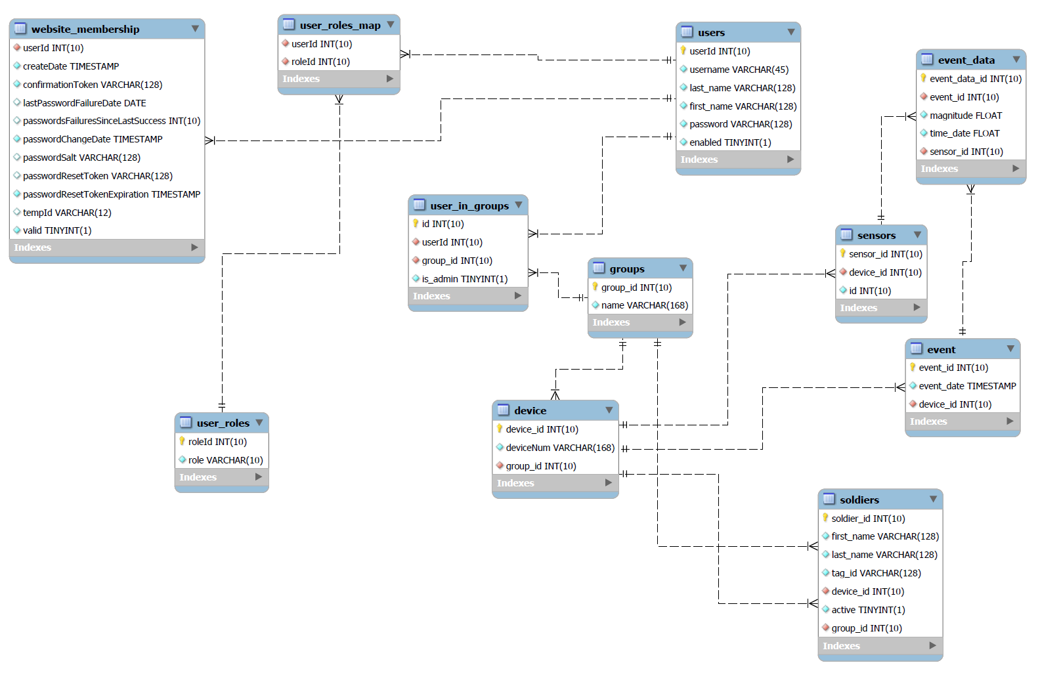

Our Shock Tube Design

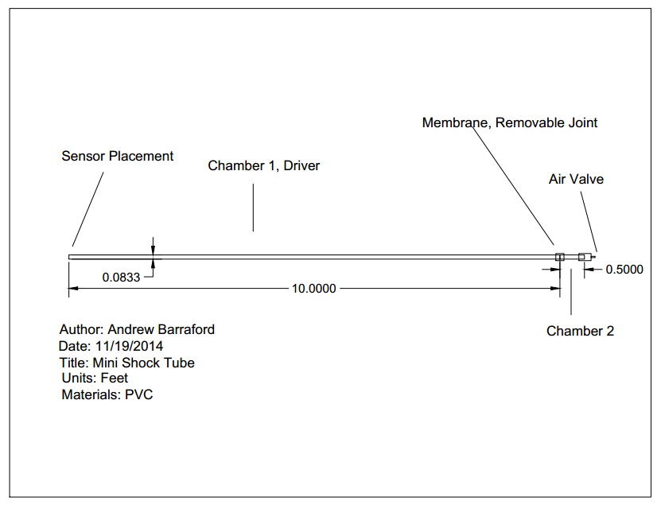

Schedule
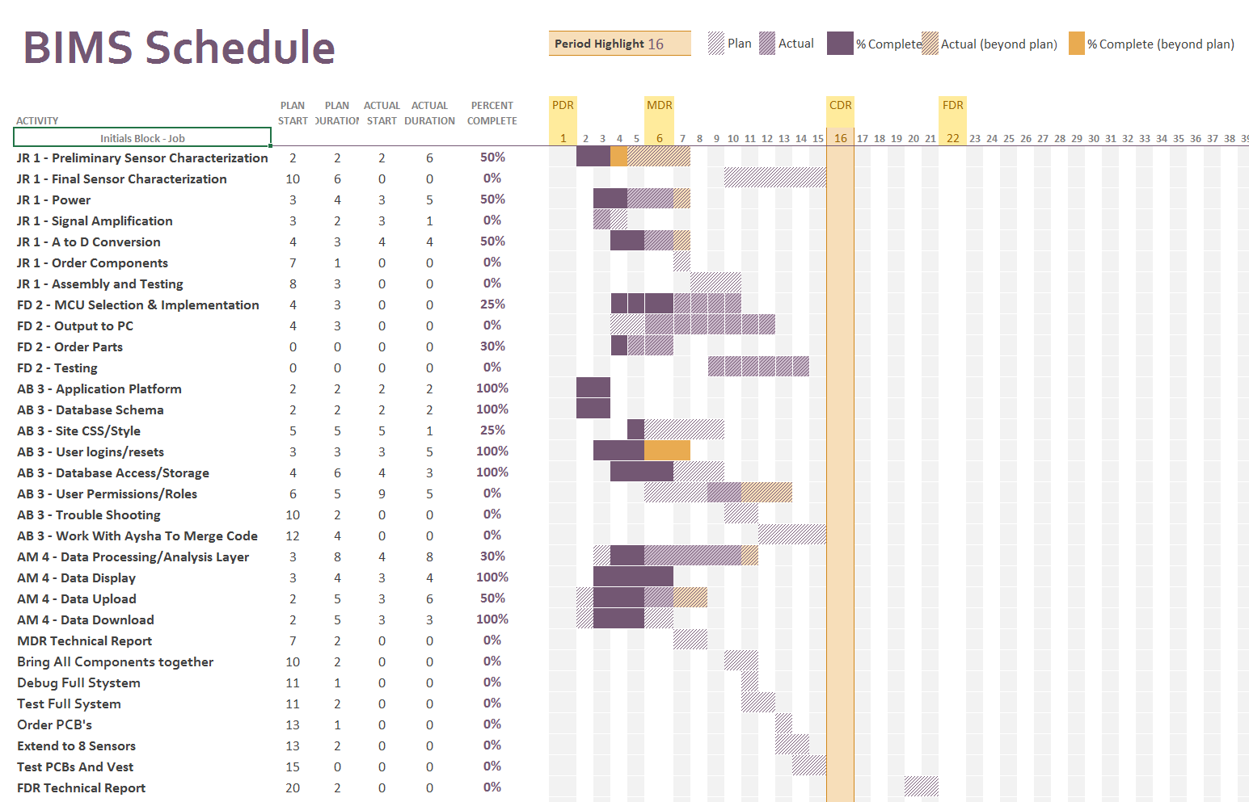

Acknowledgments
We thank our project advisor Professor Marinos Vouvakis for his support and guidance. Additionally, we would like to thank Dr. Ibolja Cernak at University of Alberta for advising our research and system requirements, Dr. YuYing Tang and Martin Muthee at UMass Polymer Science & Engineering for donating equipment and funding technical resources, and Dr. Michael Courtney at US Air Force Academy and BTG Research for advising shock tube construction.

References

[1] | "DoD Worldwide Numbers for TBI," 24 11 2014. [Online]. Available: http://dvbic.dcoe.mil/dod-worldwide-numbers-tbi.
[2] | I. Cernak, "The Truth about Traumatic Brain Injury," Institute for Defense and Government Advancement, 26 04 2011. [Online]. Available: http://www.idga.org/healthcare/articles/the-truth-about-traumatic-brain-injury/. [Accessed 24 11 2014].
[3] | The CDC, NIH, DoD, and VA Leadership Panel, "Report to Congress on Traumatic Brain Injury in the United States: Understanding the Public Health Problem among Current and Former Military Personnel," Centers for Disease Control and Prevention (CDC), the National Institutes of Health (NIH), the Department of Defense (DoD), and the Department of Veterans Affairs (VA), 2013.
[4] | K. C. Dennis, "Current Perspectives on Traumatic Brain Injury," ASHA Access Audiology, vol. 8, no. 4, August 2009.
[5] | US. Department of Veterans Affairs, "Traumatic Brain Injury and PTSD," PTSD: National Center for PTSD, 3 01 2014. [Online]. Available: http://www.ptsd.va.gov/public/problems/traumatic_brain_injury_and_ptsd.asp. [Accessed 24 11 2014].
[6] | R. L. W. C. J. P. a. S. M. Ioan Humphreys, "The Costs of Traumatic Brain Injury: A literature Review," NCBI, 26 06 2013. [Online]. Available: http://www.ncbi.nlm.nih.gov/pmc/articles/PMC3699059/. [Accessed 10 10 2014].
[7] | W. W. a. J. White, Spring in Practice, Shutter Island, NY: Manning Publications Co., 2013.
[8] | MySQL, "MySQL 5.7 Reference Manual," 24 11 2014. [Online].
[9] | J.M. Dewey, "The Shape of the Blast Wave: Studies of the Friedlander Equation", Dewey McMillin & Associate, Victoria, BC, 2010
[10] | A. Courtney et al, "Developing and Characterization of Laboratory Sale Shock Tubes for Studies of Blast Wave Effects", BTG Research, Colorado Springs, CO, 2011
[11] | Y. Andreopolous et al, "Probe to MEasure Direction and Strength of Moving Shocks or Blast Waves," City University of New York, New York, NY, 2003
[12] | Atmel Corporation, "8/16-bit Atmel XMEGA A1U Microcontroller," Atmel-8385I-AVR-ATxmega64A1U-128A1U-Datasheet, Sep. 2014
[13] | Unionfortune, "LI-POLYMER BATTERY PACKS," 585460 2000mAh Datasheet, Mar. 2006
[14] | Measurement Specialties, "DT Series Elements," DT Series Datasheet, Aug. 2014
[15] | Google Developers, "Google Visualization API Reference." [Online]. Available: https://developers.google.com/chart/interactive/docs/reference. [Accessed 15 12 2014].
[16] | The Java EE 6 Tutorial, "What Are RESTful Web Services?" [Online]. Available: http://docs.oracle.com/javaee/6/tutorial/doc/gijqy.html. [Accessed 15 12 2014].

