Umass Amherst
Adaptive Use Bridge Project
Sample assignment for instructors #2

This assignment has been designed for a junior level structural analysis course.

Develop a computer model of the Southern Vermont (1906) Bridge using MASTAN software. Utilize the autoCAD drawings available on the Adaptive Use Bridge Project website to find the dimensions of this bridge.

Create a 2-dimensional model of only one of the two trusses of the bridge. Apply a load to your model; the applied load should simulate a backhoe parked on the bridge. Assume the following when creating the computer model:
- Neglect the self-weight of the truss.
- The weight of the backhoe is 19000 lbs.
- The weight of the backhoe is evenly distributed between the two parallel trusses.
- The weight of the backhoe is evenly distributed between the two nodes L1 and L2.
- The elastic modulus of the truss material is 29000 ksi.
- The yield stress of the material is 30 ksi.

Model the bridge with two pinned external boundary conditions (at nodes L0 and L3). Try to also model the bridge with a single pin connection at L0 and a roller connection at L3.

This load test was performed and resulted in a downward displacement at node L1 of approximately 0.15 inches, and at L2 of 0.16 inches.

- How do your simulation displacements compare to these load test results?
- Can you offer any explanation to the discrepancies?
- Provide MASTAN plots of deflected shape and axial force.
- Fill out the attached form with computer simulation input and result information.

The following web site links may be helpful:

- The Adaptive Use Bridge Project homepage:
http://www.ecs.umass.edu/adaptive_bridge_use/index.html

- The Southern Vermont (1906) Bridge webpage:
http://www.ecs.umass.edu/adaptive_bridge_use/bridge_files/
sVermont1906Bridge/sVermont1906Bridge.html

This bridge’s webpage can also be accessed by clicking on “data” then “Southern Vermont (1906) Bridge” from the project’s homepage.
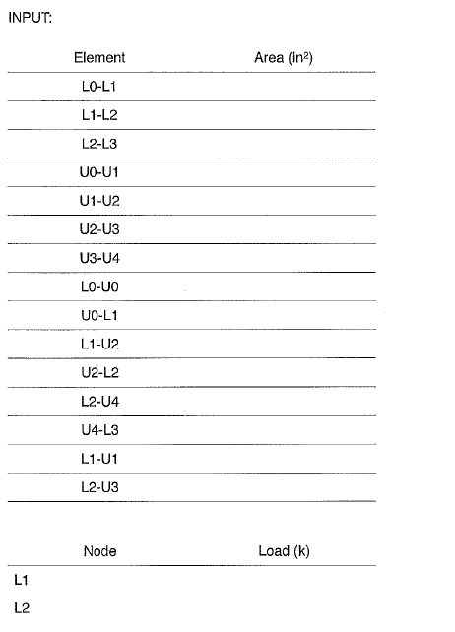

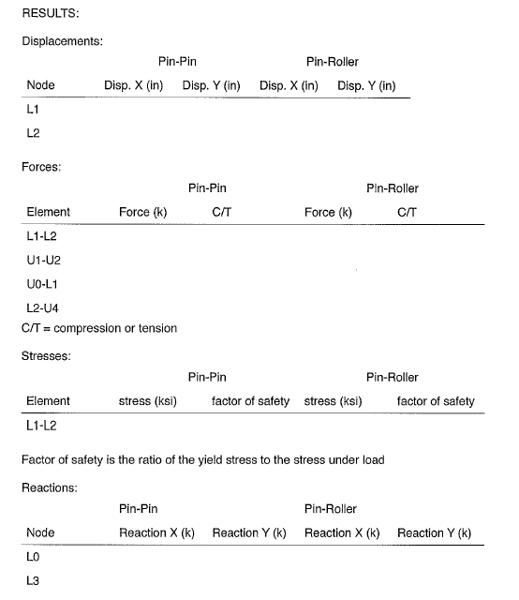

Solutions:

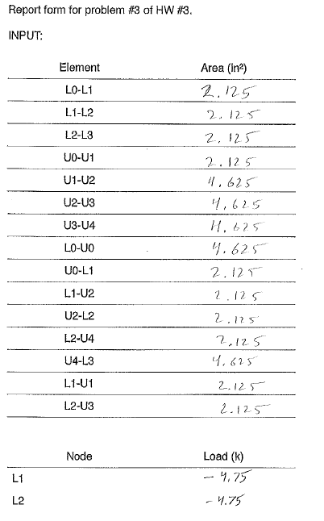

Solutions continued:

