UMass Amherst
Adaptive Use Bridge Project
Golden Hill Road Bridge Hardness Test Methods
Hardness data was collected on the 4 tensile coupons from the Golden Hill Road Bridge before they went through destructive testing. The Rockwell B test was performed in accordance to ASTM E18-03. A 1/16 inch ball indenter was used with 100 kg of test force.
A total of 8 readings were taken on each specimen. The process for data collection was made uniform to increase precision. The location of the indentation for each reading is shown in Figure 1.
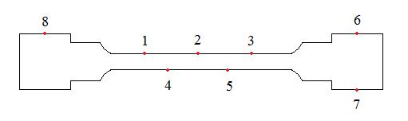
Figure 1. Hardness test locations.

