UMass Amherst
Adaptive Use Bridge Project
North Chester Village Bridge Tension Test Methods
For the North Chester Village Bridge four tension coupons were created from one beam hanger, and five coupons were machined from two lacing members cut off the bridge’s guard rail. Tension testing was performed in accordance to ASTM E8-04.
The wrought iron material obtained from the beam hanger was machined into round coupons with a gauge diameter of 0.5 inches. The dimensions of the tension coupons can be seen in Figure 1. The coupons were held in the tension machine by custom made shoulder grips. Figure 2 features a photograph of the tension grips.
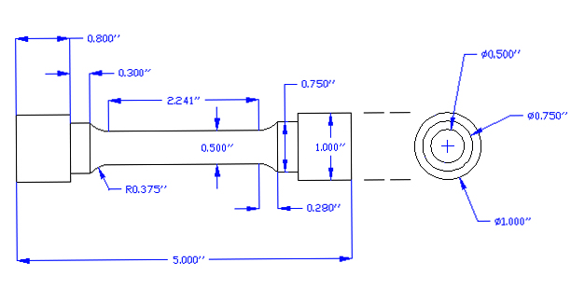
Figure 1. Round type tension coupon used for material from beam hangers.

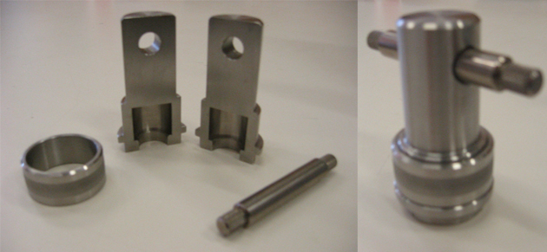
Figure 2. Custom made shoulder grips used to hold the tension coupons during testing.

The wrought iron obtained from the lacing members was machined into plate type specimens with 0.2 inch thickness and 0.5 inch width gage section; dimensions of this coupon type can be seen in Figure 3.
Figure 3. Plate type tension coupon used for material from lacing members.
While testing, the specimens were subject to 0.005 inches of strain per minute until 20 ksi of stress was reached. During this time, an extensometer was used to accurately measure strain. After 20 ksi of stress was reached, the extensometer was removed and the strain rate was increased to 0.05 inches per minute. The testing machine's cross head displacements were used to record strain measurements after the extensometer was removed. Testing continued until the specimen failed.
The extensometer is an accurate yet fragile measurement tool. To avoid damaging this piece of equipment it was removed while each test was still in progress. It was found that the cross head displacement measurements made by the testing machine were precise however inaccurate. A method to correct the results and remove this inaccuracy was developed and applied to all of the raw data. The stress-strain elastic range's linear behavior was used to correct misleading data. Figure 4 includes uncorrected and corrected stress strain plots for a tension sample.

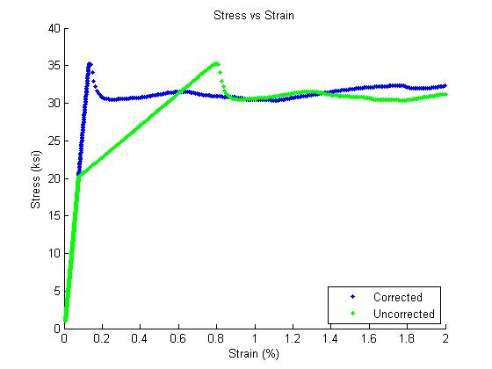
Figure 4. Uncorrected and corrected stress strain diagrams.

The tension test results provide valuable information on the material at hand. The modulus of elasticity, yield strength, tensile strength and percent elongation at failure can all be obtained from tension testing. These material properties are used when planning reconstruction of historic bridges.

